Keegan van Niekerk: Level 3 AS91903 Digital Media Outcome

# Plan:

For my DMO I choose to make a website:

My website is to be a blog/gallery of projects I am working on. I plan to have a homepage that shows the different things I am working on, 2-3 pages for each of these projects and a final page that is an about me section. The software that I will be using to code the website is called Atom, it has an easy to use UI and allows you to easily import libraries and useful plugins as necessary.

The purpose of my website is to store and display the drawings I have made as part of my friend group’s chats in order for them to revisit them as well as pixel art that I have been working on. I need to make sure that my website has common useability heuristics in order for it to be functional to end users.

User Experience Principles:  
Match between system and the real world: No overly technical language is used within the UI of the website, it is all written in layman’s terms.

Consistency: I need to include consistency of design across all pages especially in colours, placements of logos/navigation bars and shapes.

Simplicity: I will not overwhelm the user with options and reduce the number of buttons required to navigate things. Etc in a gallery by only including a maximum amount of 3 elements that can be clicked when an image is enlarged.

User control and freedom: I will ensure that any elements of my website that cause you to become locked out of interacting with the rest of the site. E.g. a photo viewing pop-up of a gallery will have a visible “x/exit” button and will can also be exited by clicking outside of the box’s area.

Aesthetic and minimalist design: My design will not overwhelm the user with options and all interactive elements and links will be labelled clearly so users will not have to search in order to find out what is interactable or not.

Testing procedures:

My log will show the creation of my website over time as well as any changes I make to the design or functionality. I will include screenshots of the tests I perform to make sure it works properly on all devices and across several popular browsers. For each page I work on I will include a section at the end that includes specifically mobile browser testing and how I worked to fix any issues that arose from that.

I will also use GitHub commits regularly in order to roll back my website to a state in which it worked and solve the problem from both ends in the case of a major problem.

Implications:  
Intellectual Property: I need to make sure that I have permission to use and all photos that are on my website. I am going to address this by using my own drawings or art as the images and either using royalty free logo icons or making them myself.

Useability: The website should be easy to use and navigate. I will make sure my website fulfils this by having a clear navigation bar along the top. I will also adhere to common design and useability heuristics as described above and throughout this log.

Functionality: The website will be functional as intended. End-users will need to be able to look at the website on any browser such as chrome, firefox and Microsoft edge as well as with their mobile phones. I will use testing procedures as described earlier in order to fulfil this.

## Complex techniques:

* Sophisticated digital effects: By using techniques such as parallax scrolling and a gallery with dynamic effects that can be clicked to enlarge images within them, I plan to have a website with effects that hold up to today’s standards in web viewing.
* Responsive design for use on multiple devices: I will make sure that my website can be viewed on both mobile devices as well as on PC and with several different browsers.
* Automation through scripts: I plan to have my gallery automatically update by drawing its images from a Dropbox where I can simply upload my image and it appears on the website. This will be achieved through using scripts.
* Integration of original media assets: I will address this by mainly using my own drawings and designs for logos on the website. I will design extra elements for the purpose of enhancing the previously listed techniques.

Design:

I started out by creating some Wireframe designs for my website

Homepage: Drawings/Posts:

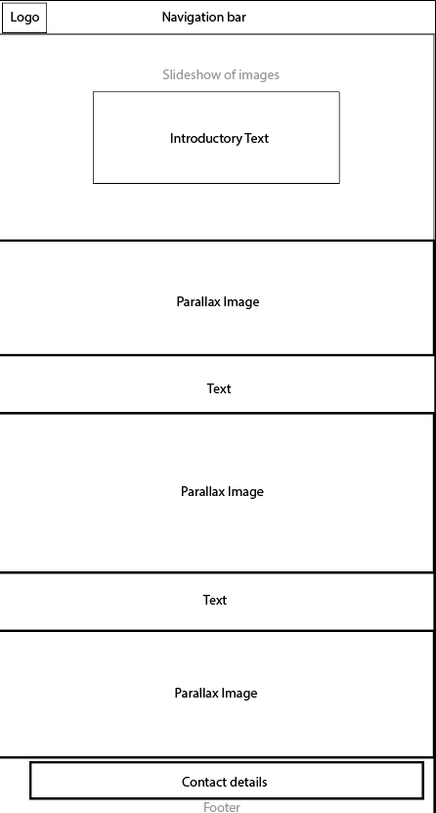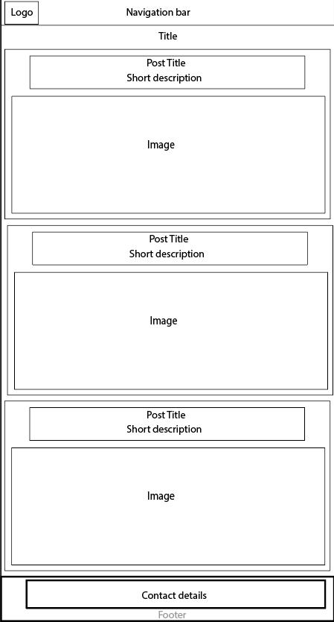

Pixel Art Gallery:

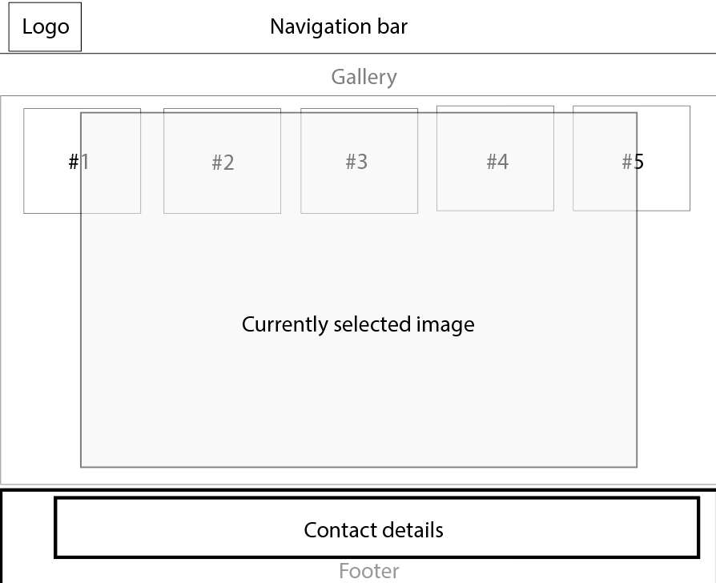

Log:

I started off by making a 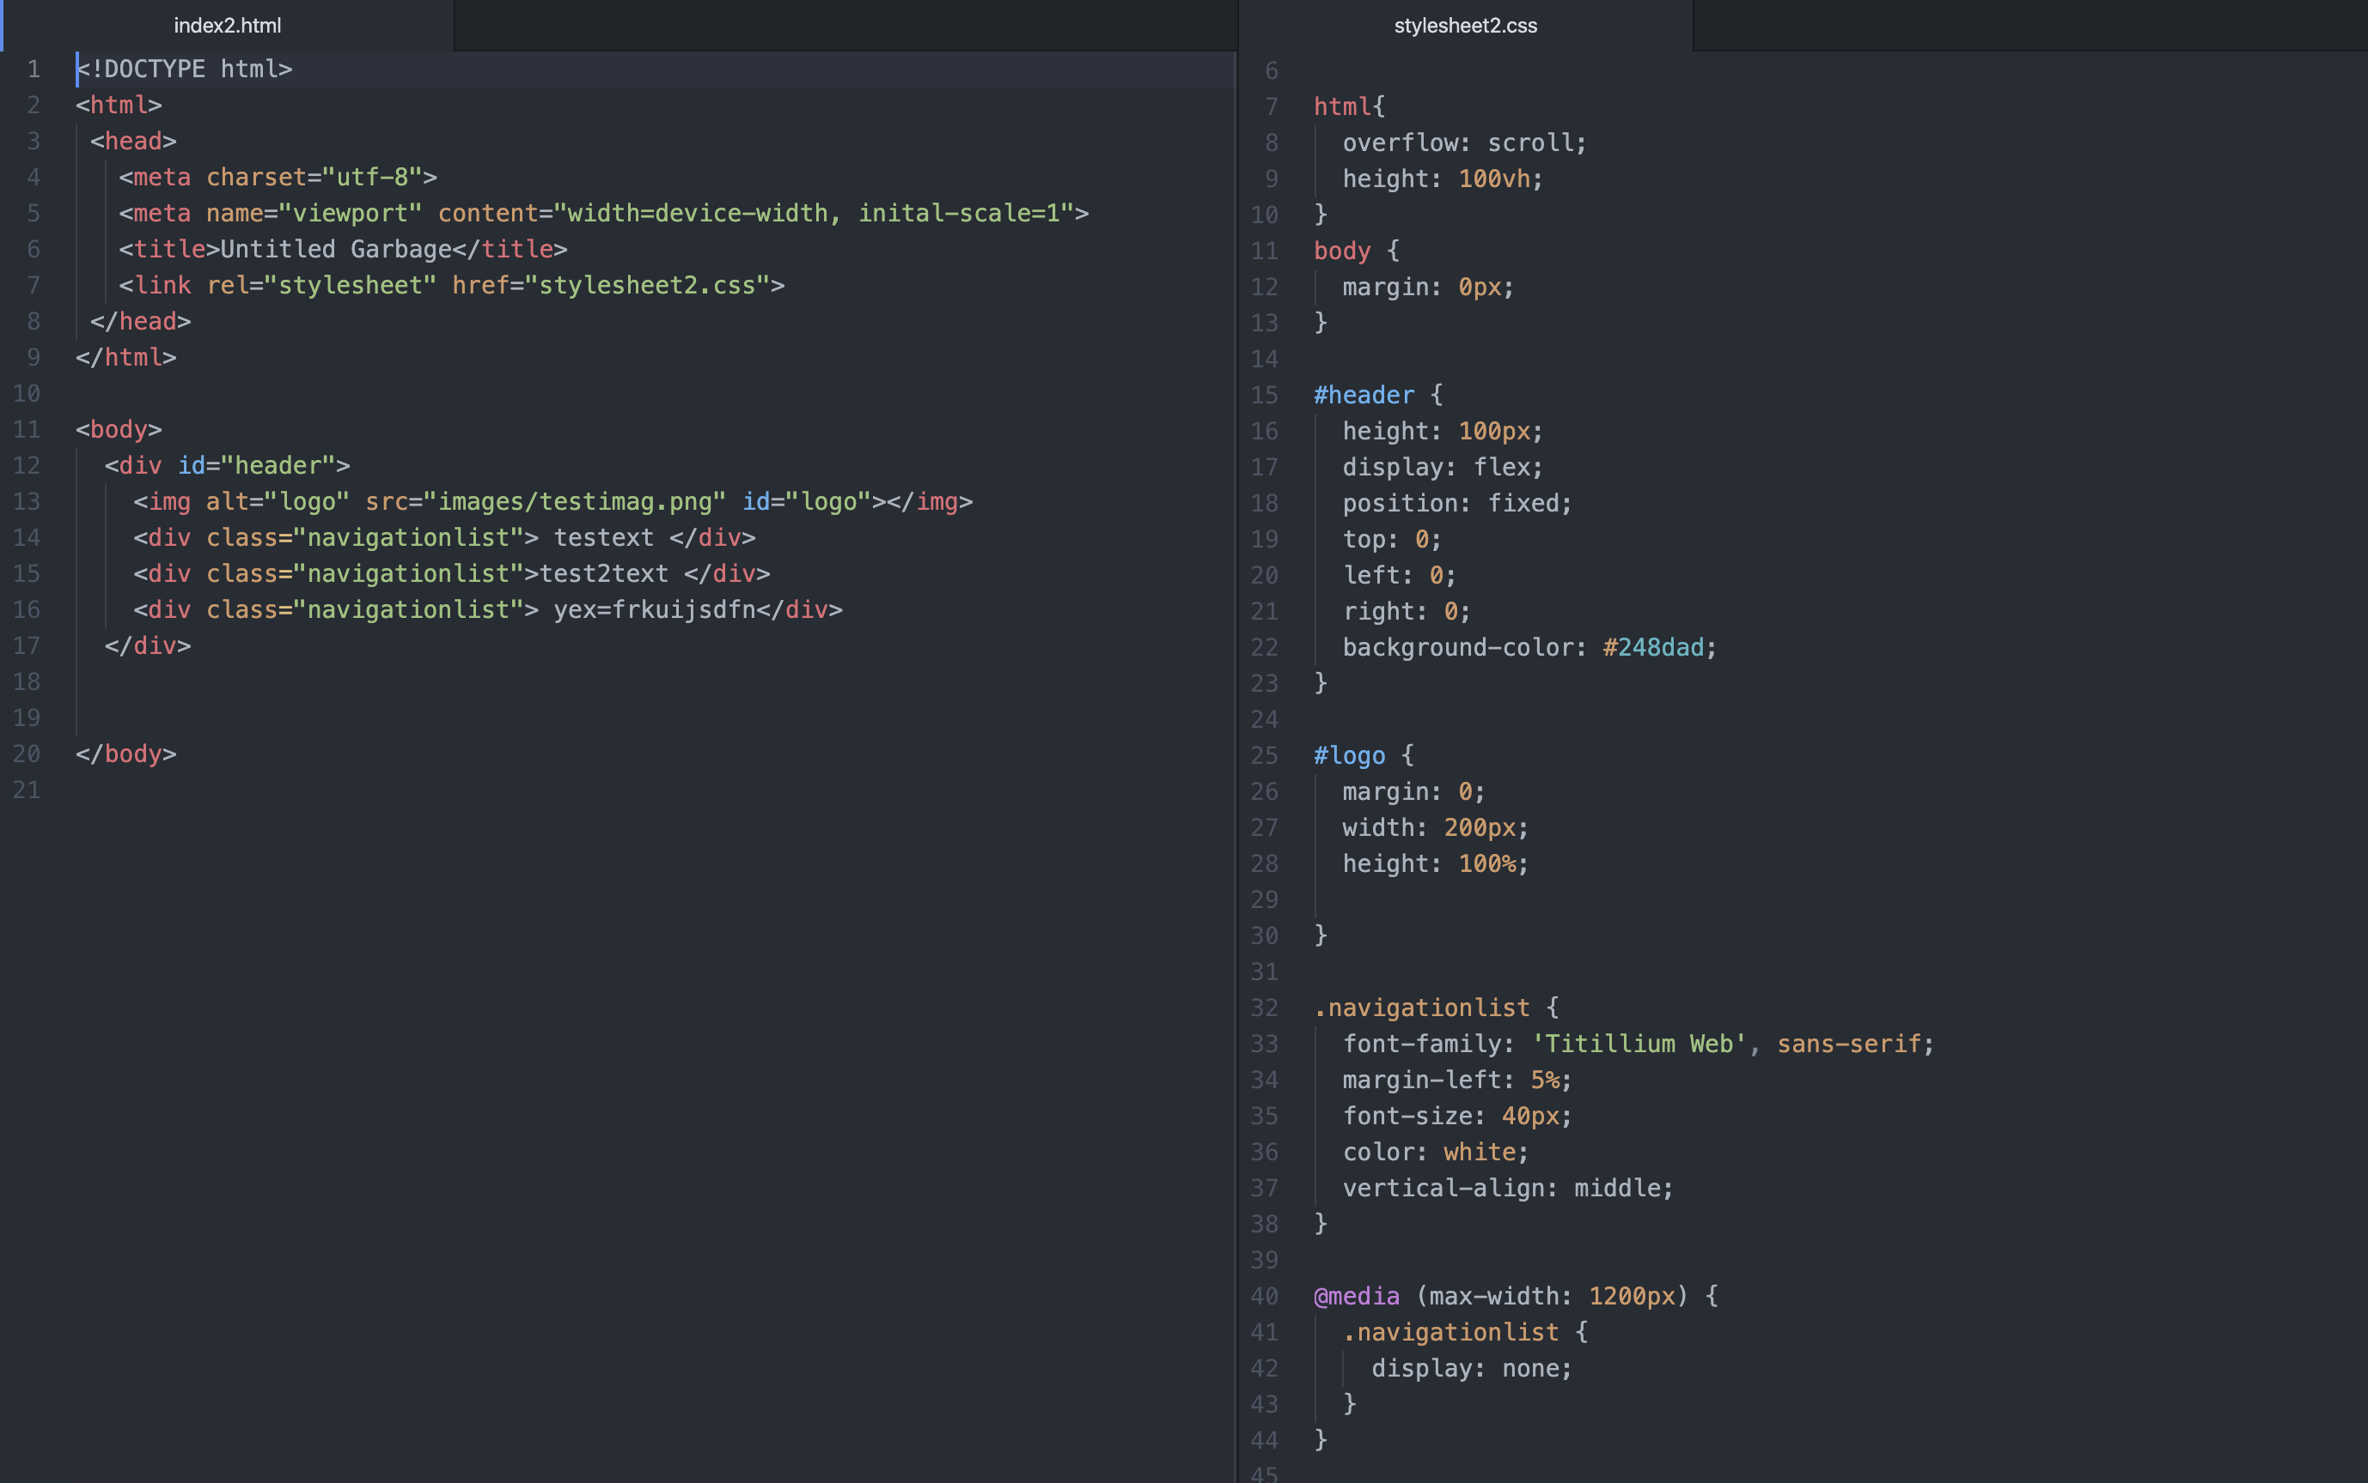generic header with a placeholder logo image in the top left.

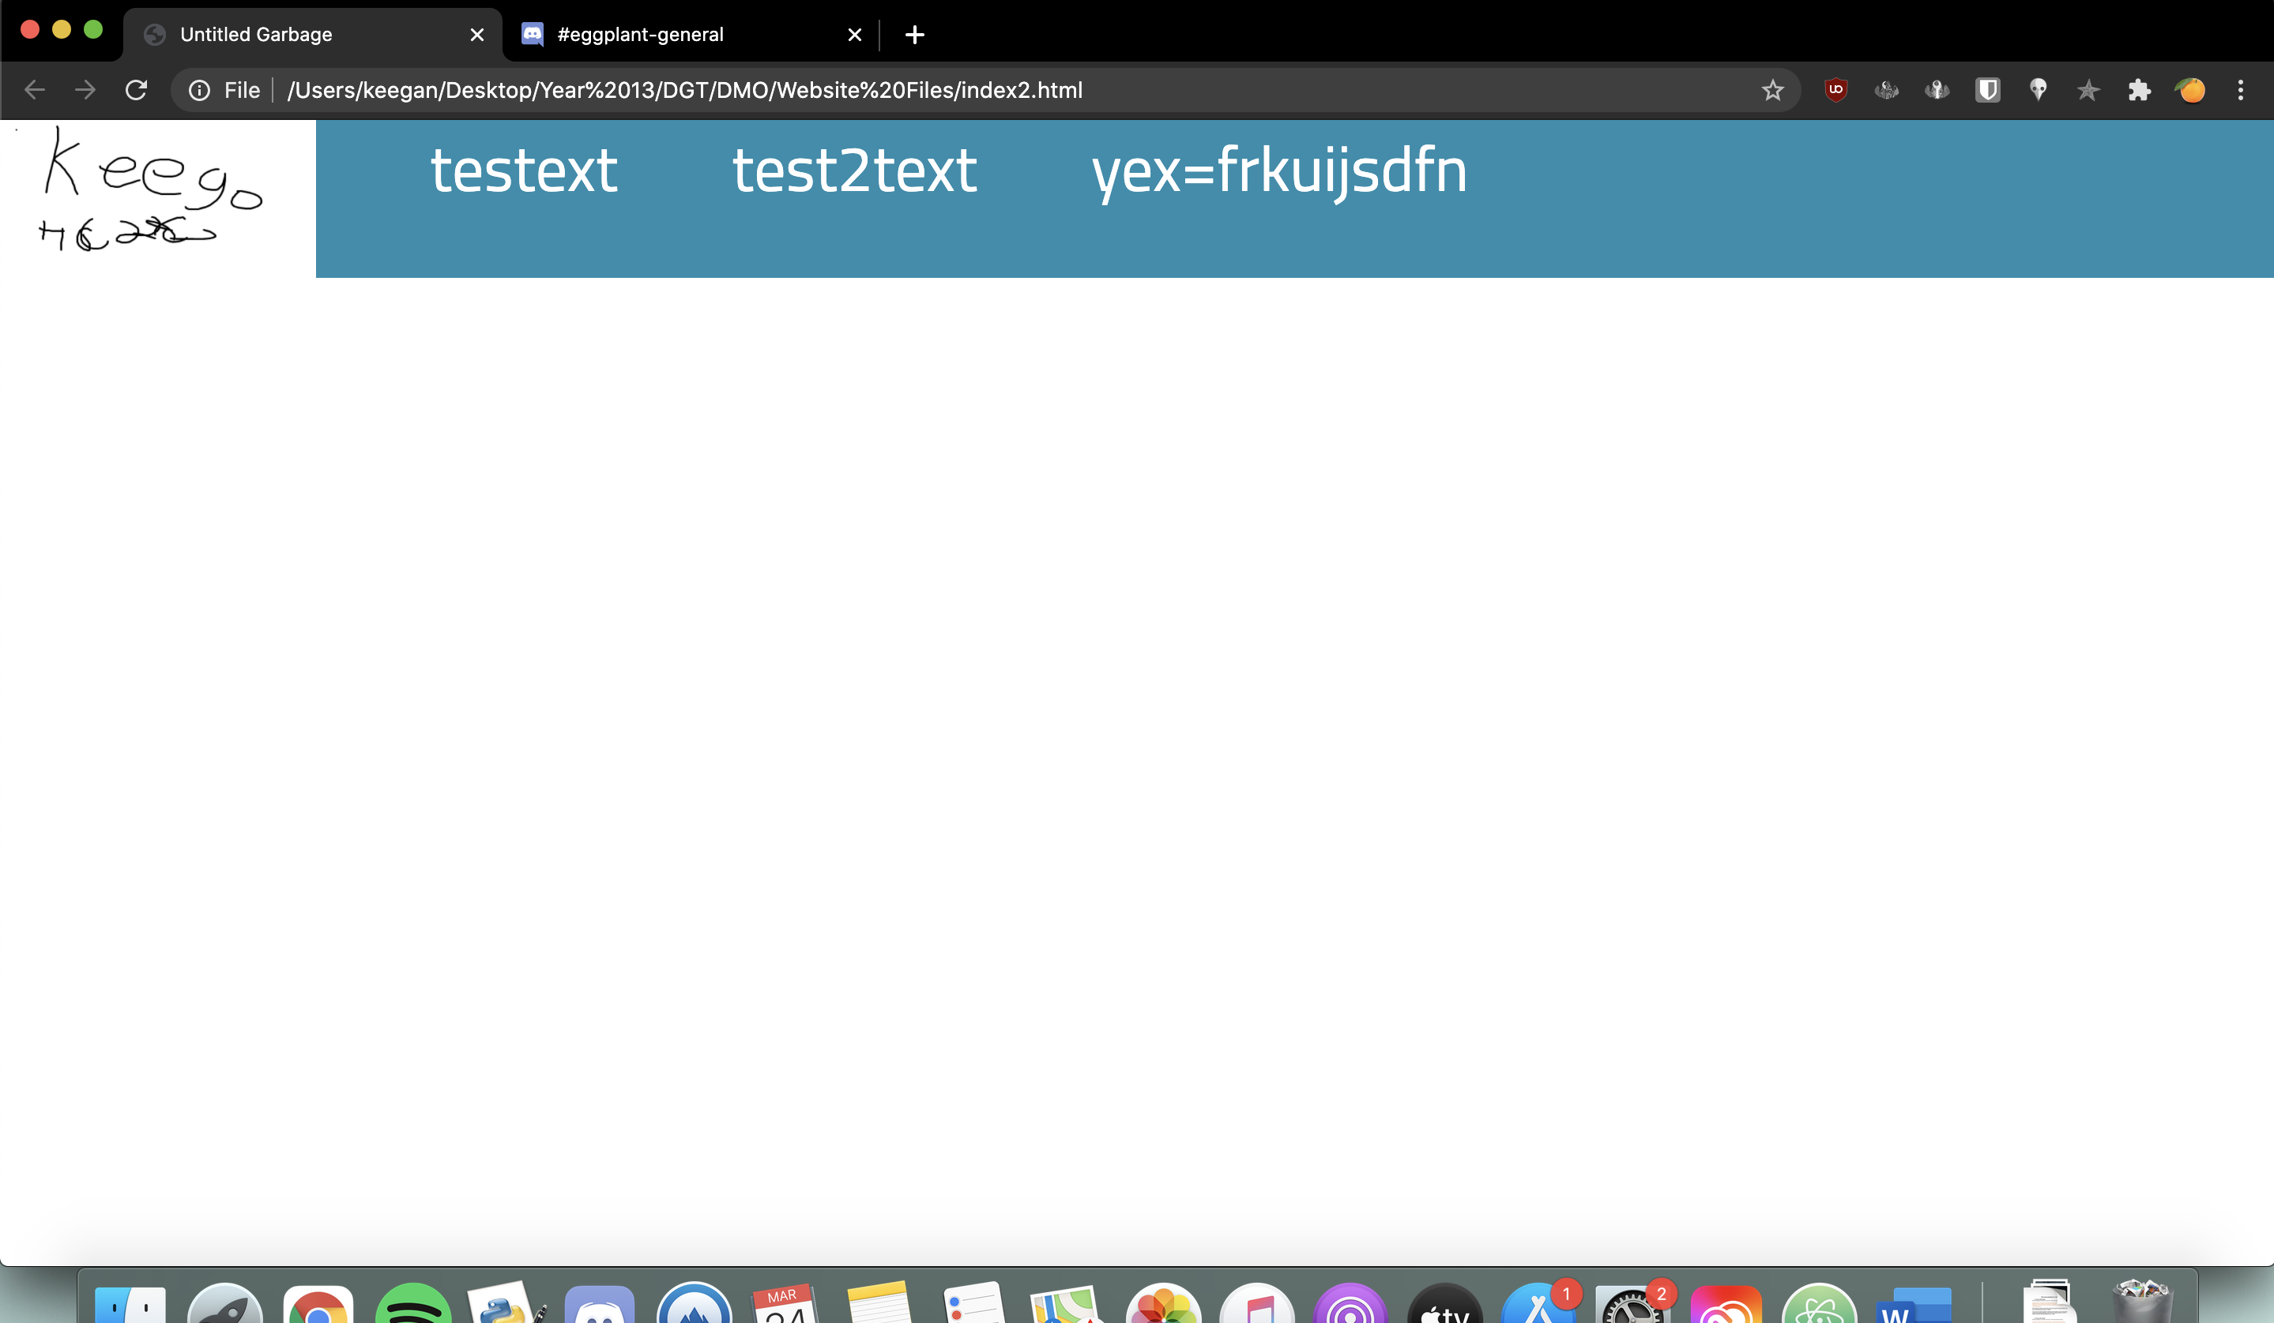

However the header was not aligned along the vertical axis and it was using divs instead of lists. I switched to using an unordered list and added a margin in order to center the text. I set the header to be in a fixed position which meant that it would not disappear from the top of the screen even as the use scrolled. This is part of my useability implications as users expect to be able to navigate to any page from the top of the screen while using a website on a desktop format. It also means I can make my homepage as long as I like as users will not need to scroll all the way to the top in order to see the navigation menu.

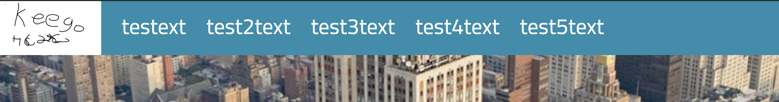

I also used a media query to make the header disappear if the screen is less than 1200px wide.

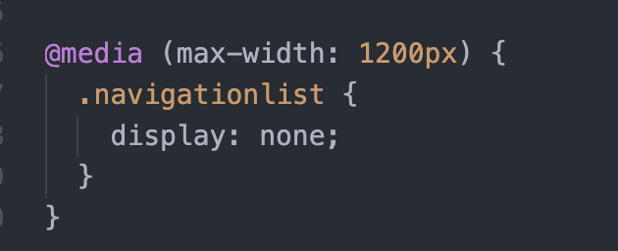

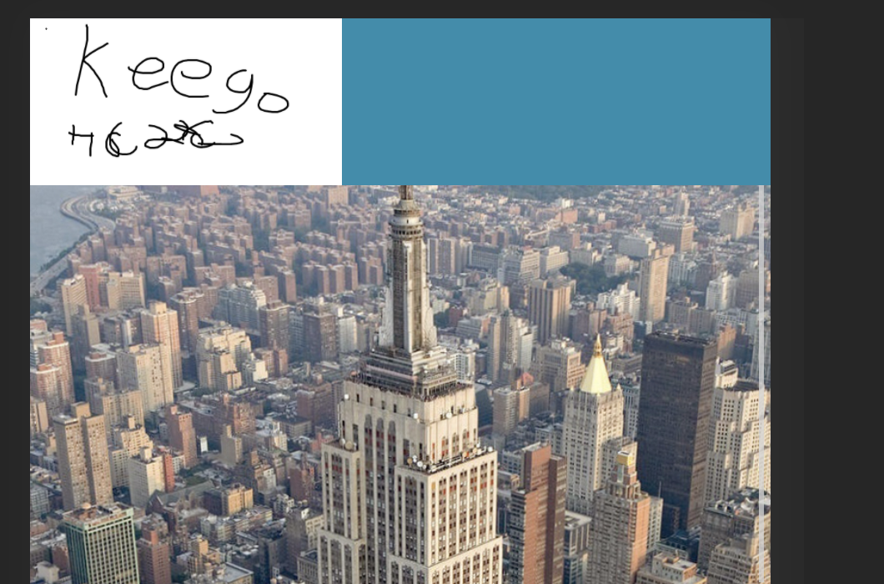

In the future I will convert this further on mobile so that it becomes a vertical menu without a fixed position on the screen.

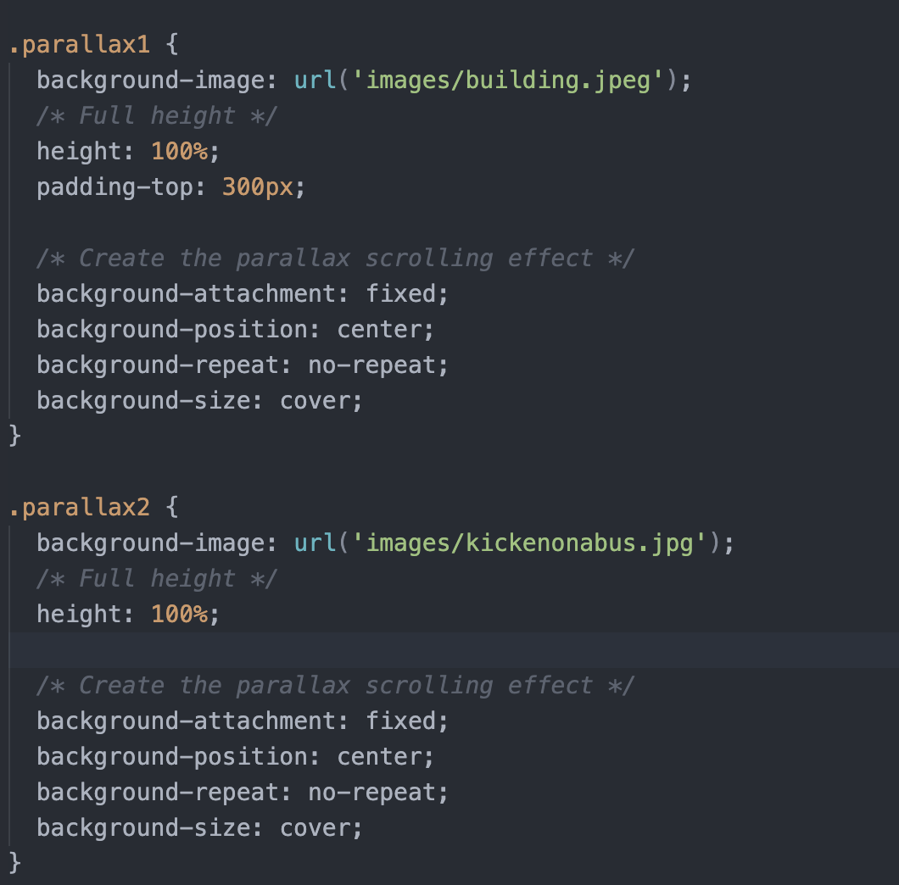The next thing I wanted to work on my first complex technique which was parallax scrolling for my homepage. I created 2 css classes and copied the parallax code so that I could have 2 images to flick between, I selected 2 random photos from my photo library to test it.

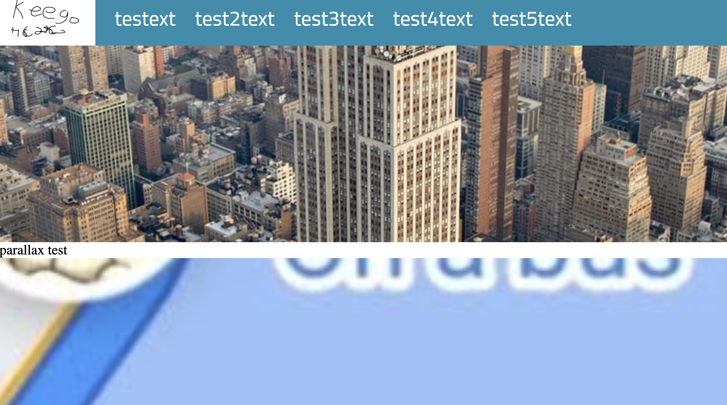

As I scrolled more of one image would reveal while the other image disappeared. However I thought it was unnecessary for me to keep creating new IDs or Classes for each time I wanted to add a parallax scrolling element. This I created a single CSS class called parallax that looks like this 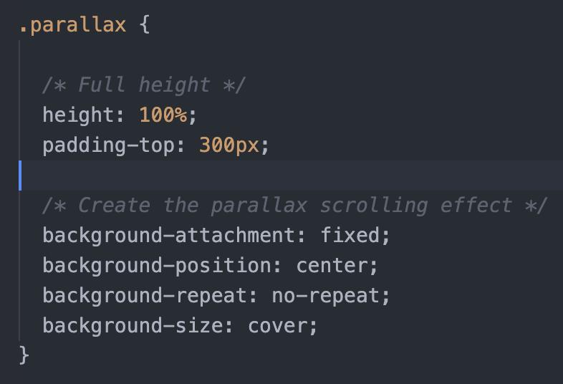

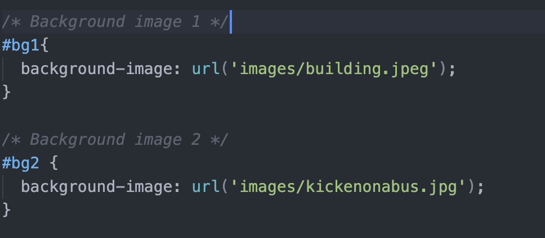I then define my background images within a separate CSS id that is used only once in the homepage. This means that I am repeating less code and have an easier way to chance background images for each parallax section. See Below

Example of usage:

This was a much improved design as I can avoid adding CSS styling within my HTML document and I can change this image for a mobile layout in the future using media queries.

The next thing I did was add a section in the first parallax image that could house an image or text and would scroll up.

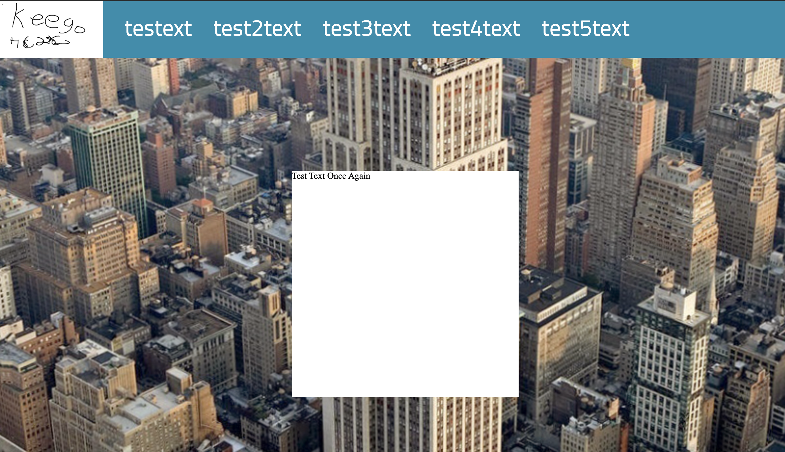

I added a total of 4 parallax images and text descriptors and created a footer at the bottom of the website. I plan to change this design in the future as while parallax is a complex addition to a website I don’t want to use its most basic form.

The next thing I worked on was a footer for the website. It’s a simple coloured full width div that sits at the bottom of my website. [The blue at the bottom]

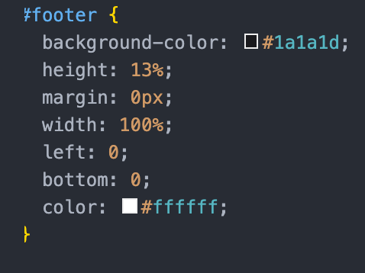

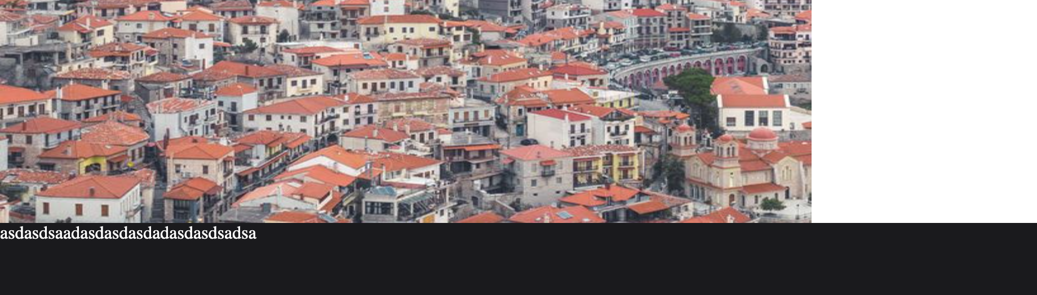

A footer is relatively simple to code so I moved on to changing how my parallax worked

I started working on a design where 50% of the screen’s width would be image and 50% would be a box that could hold text.

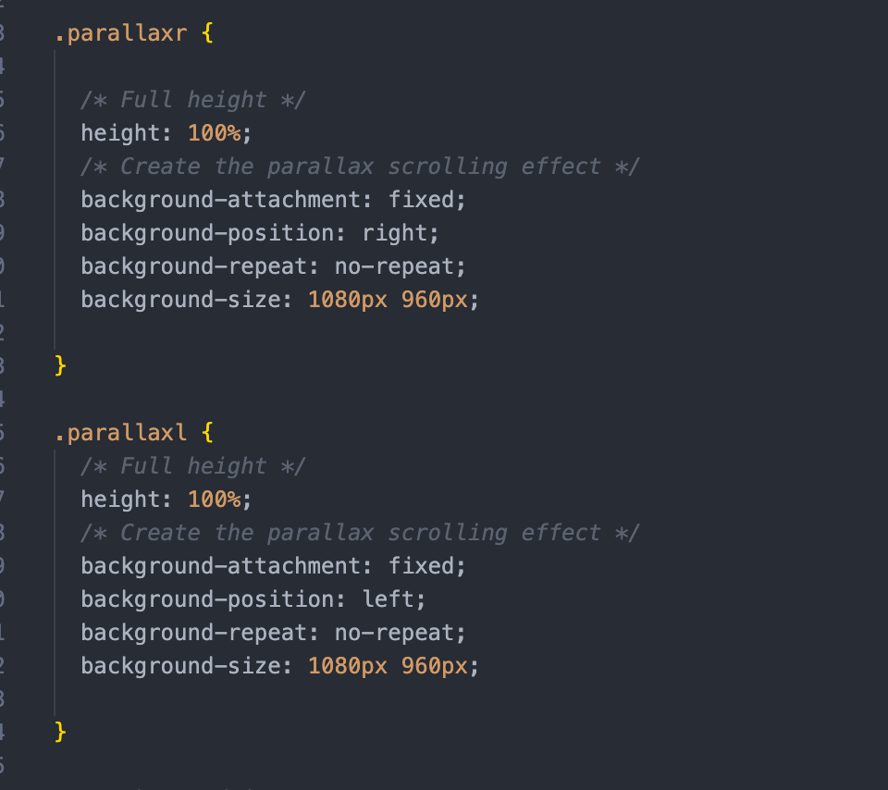First I adjusted my parallax code to have different classes for the left and right based images.

The background attachment is adjusted left and right depending on the design. I also wrote code that makes a div float left or right for positioning of the text area.

Example of a join: 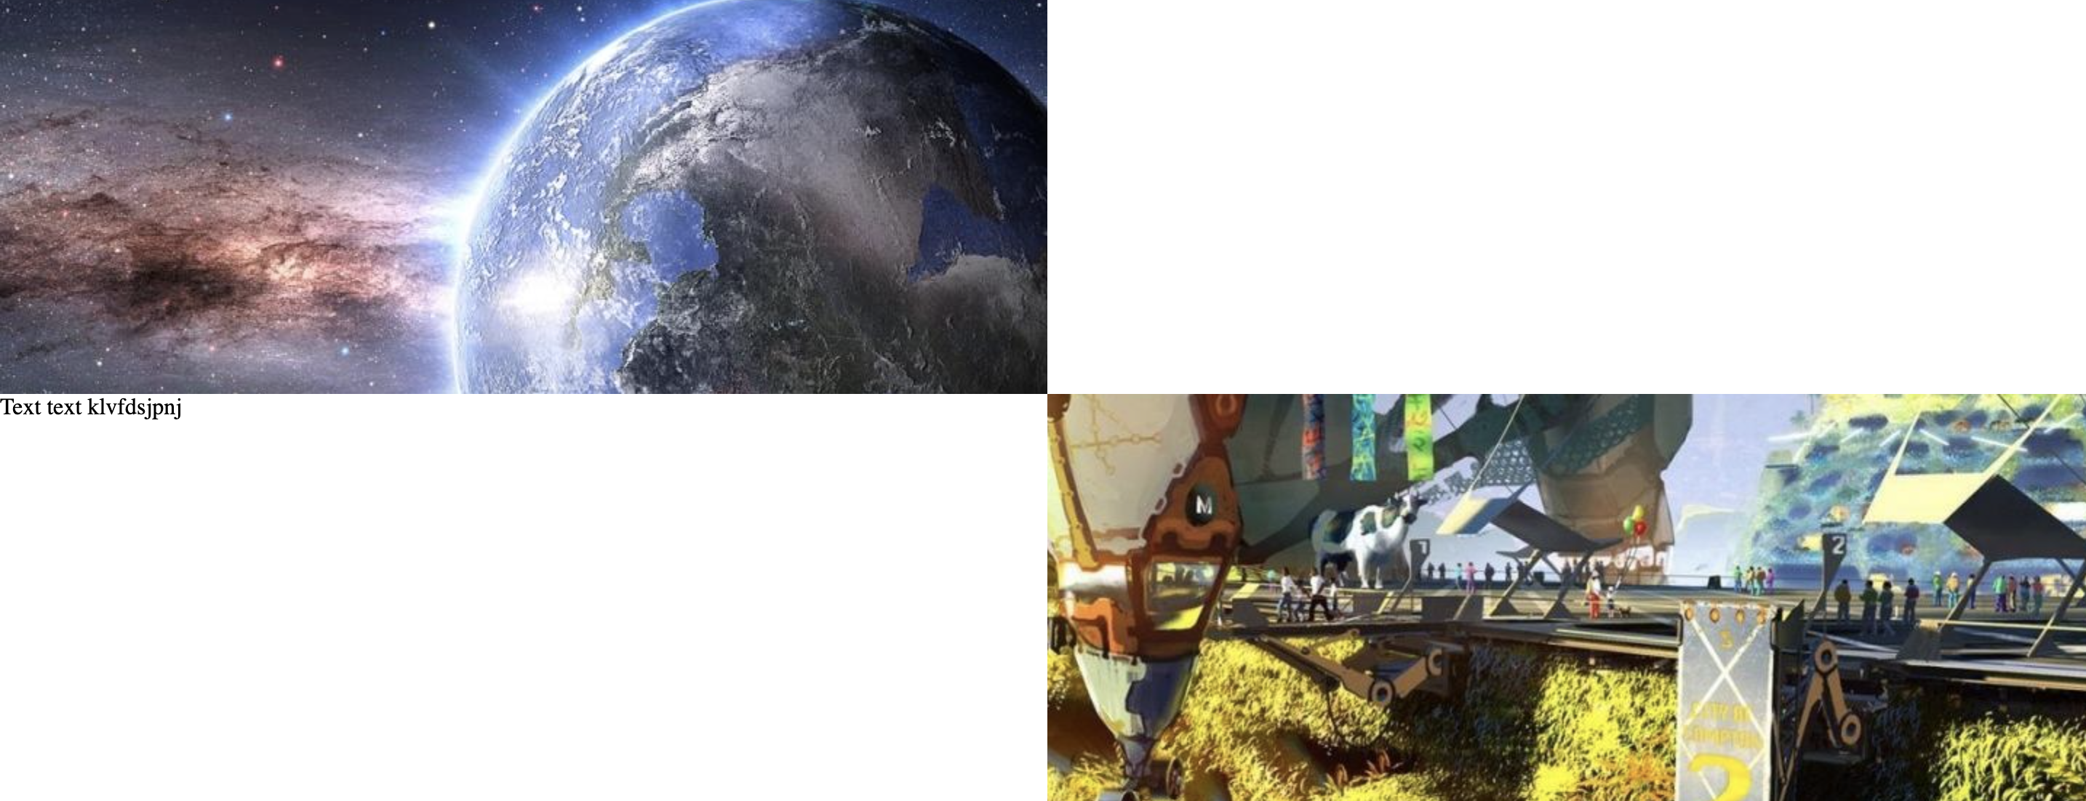

This is part of my aesthetics implications as it looks much nicer than the single solid image parallax and fits with the modern design theme of my website.

Designing Template:

Now that there is functionality to my homepage the next step is to turn my current design into a template.

The first step is to make functioning footer links, make minor changes to my header and split my document into multiple stylesheets.

I asked for advice from design students on what would be a good colour for my header and footer backgrounds. I reviewed this a few times with them and decided on a charcoal colour. 

I used a footer design from one of my previous projects and edited the background colour to match the header. This was done in order to streamline and optimise design time.



After implementation of the new header I realised I had neglected to add the original png files for the link images to my project folder so I did so and adjusted the css to match how I wanted it to look. This the finished footer.

Having finished the header and footer I wanted to create a second CSS document that would include all of the fonts.



I split my current CSS file into these two. One had all of the CSS I would need on every page such as edits to <body> and <ul> as well as the styling for my header and footer. You can easily see this difference in my media queries across the two files.

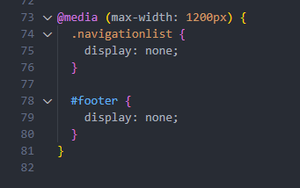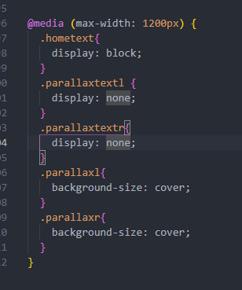

With this my “all page” template was complete.

Homepage Stylising:

I used a generic sunset picture I took myself as the background when you first open the page. I made a PNG of some text in photoshop to use as welcome text.

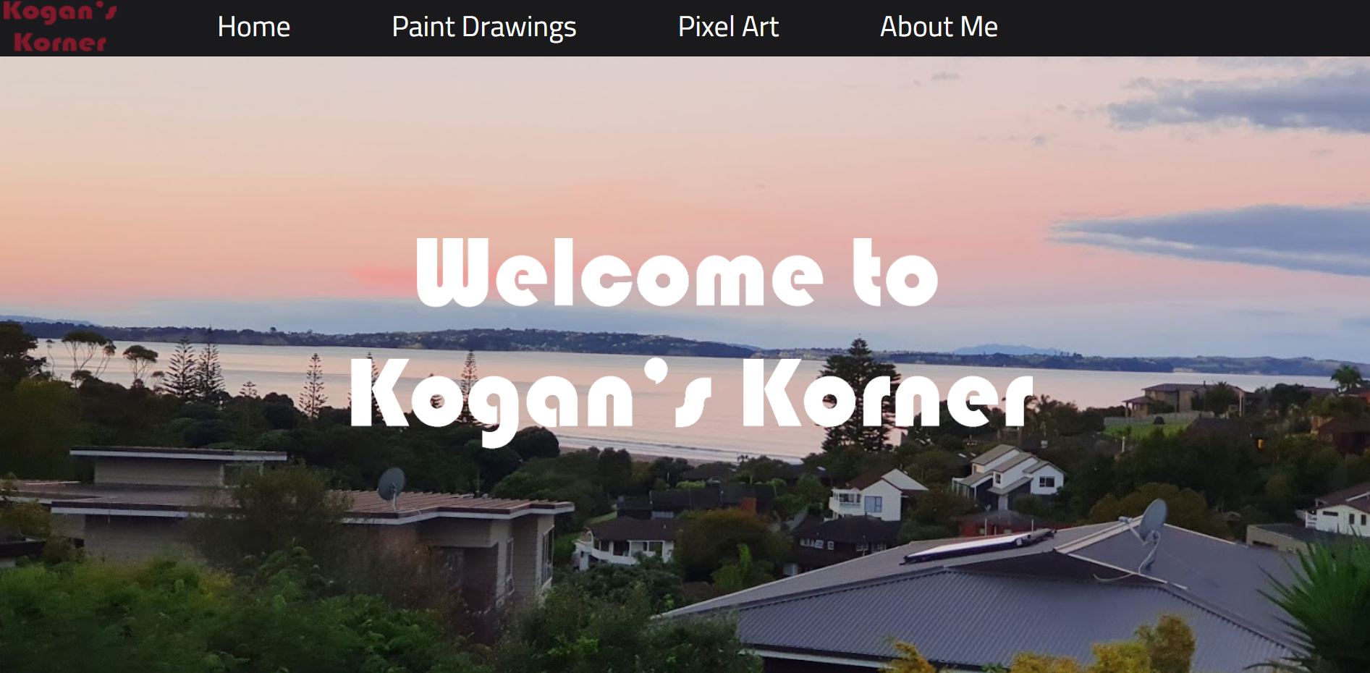

The logo in the top left is most likely going to change over time. I tried to create a collage of some of my paint drawings as an image to represent that category however it did not look good, and I instead decided on a vector image of the paint logo itself. 

After selecting some images, I got working on the text and link boxes. 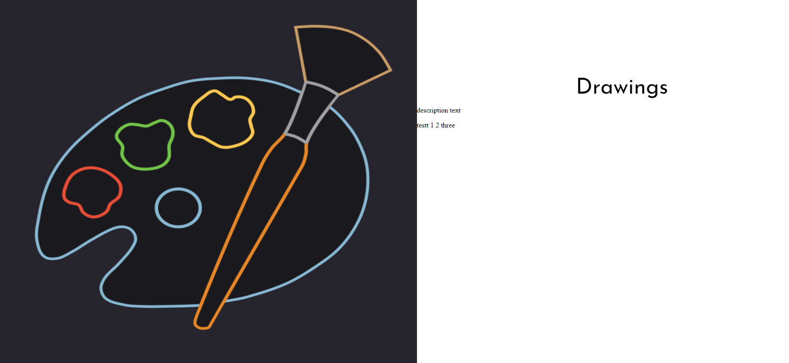

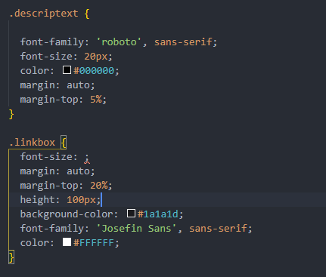I found that when loading the page the margins as well as selected background colours would not load as seen above. This was an error caused by the fact that I had not given these elements a fixed width. Something that is needed in order to use the auto margin feature.

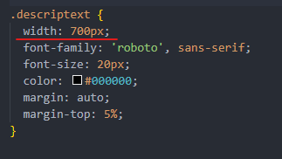It worked after adding in fixed widths

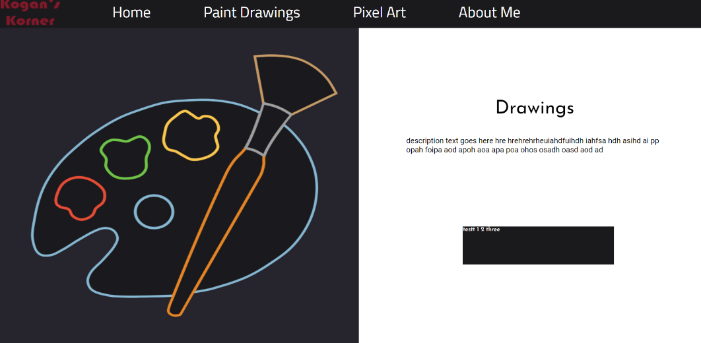

I then wrote descriptions for each section and gave the buttons titles.

After finishing the original design I tested in mobile view and noticed that it 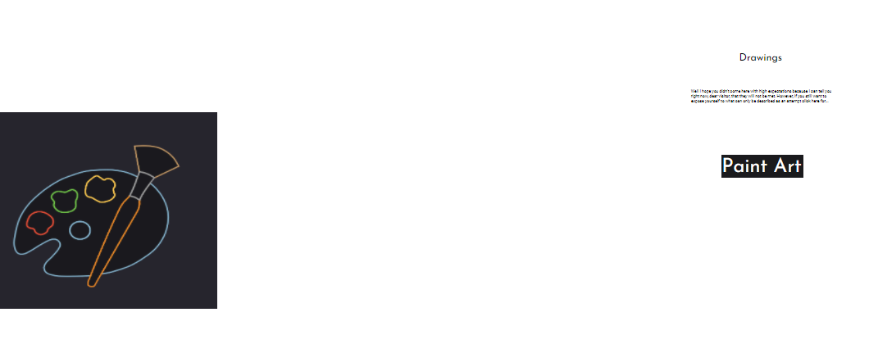was broken. After attempting to patch my current design to work on mobile I instead decided on creating a simple different parallax section.

It looked like this [mid scroll]: 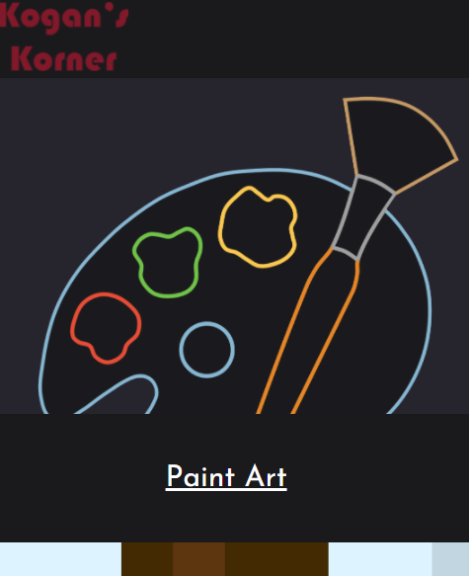

I refined this design over time and received feedback on how to make sure users knew that the text was clickable.

After having finished styling my homepage I realised I neglected to link my navigation bar to my different pages. This was a simple fix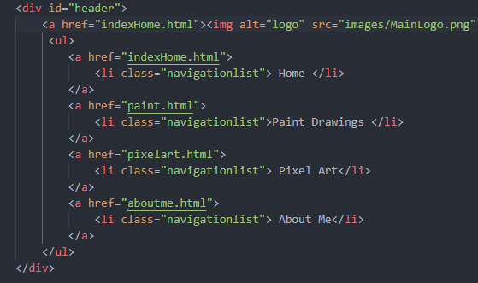

With this homepage design is completed unless I choose to edit it later if there is time.

I also have files for each of the other pages set up with my template header and footer. 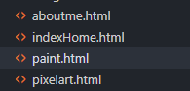

Start work on paint image page:

The design for this page is relatively simple compared to the others as it is a simple infinite scrolling image + text set. This format works best for the type of page this will be. There will be more complex ways of displaying images used in a later page.

I started off by picking a different background colour to the plain white as white is most likely going to be the colour of the background of the text. For now I used a faded purple colour to test. This was the result of my first test: 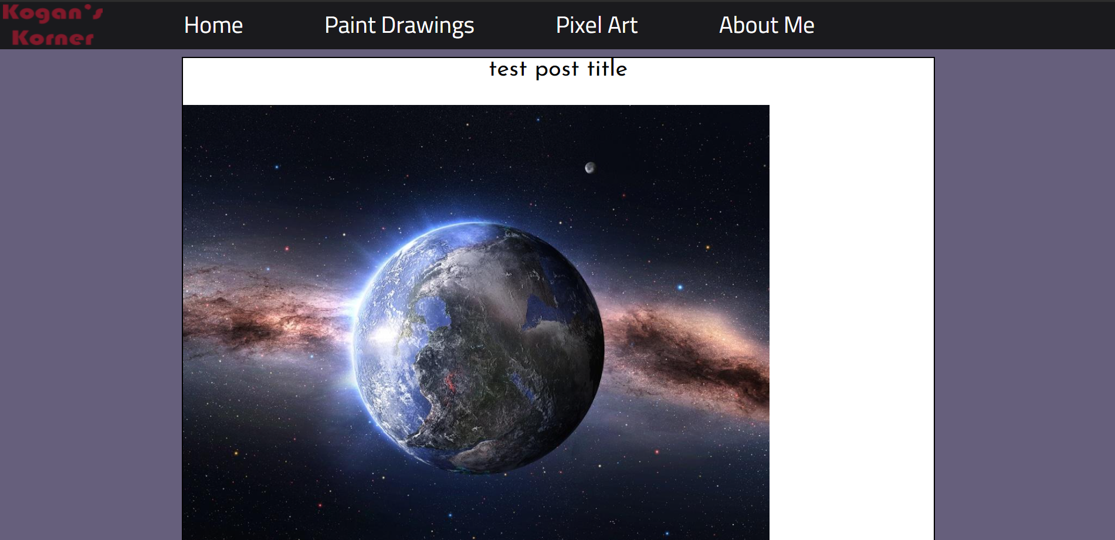

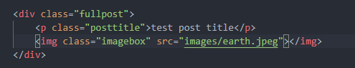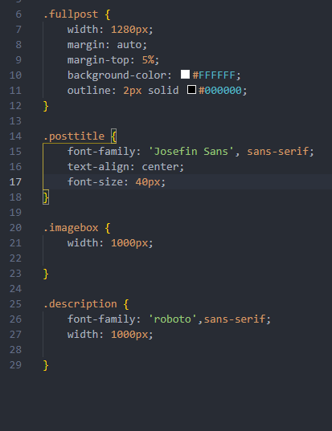 While there are terms specifying centering in the CSS the image in the test does not centre itself

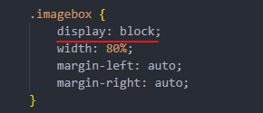After debugging using chrome’s inspect element feature, I found that the source of the problem was that the display type of the image was not block. By adding this line the image became centred

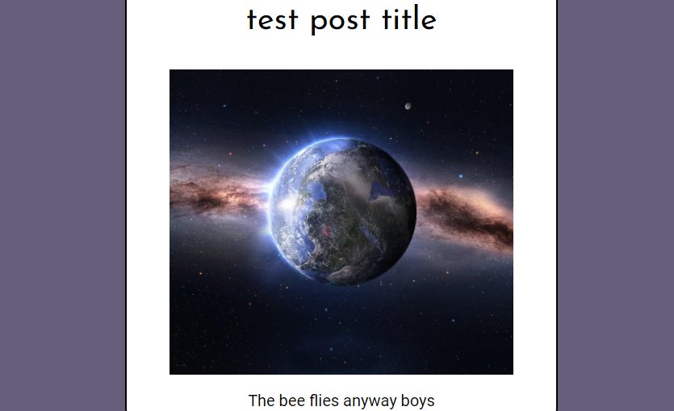

My drawings/blog page is now functionally complete. All that is left is to style it.

Styling and creating posts:

I collected 4 drawings to make example posts with.

I first copied the post design from earlier 5 times. I wrote it in such a way that once the code for a post is written it can be collapsed so that it takes up less visual space. 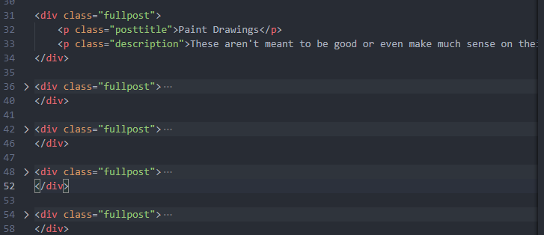

Here is the title page and a post as an example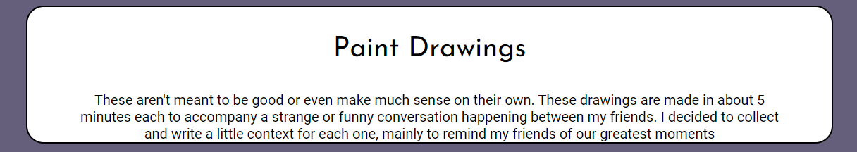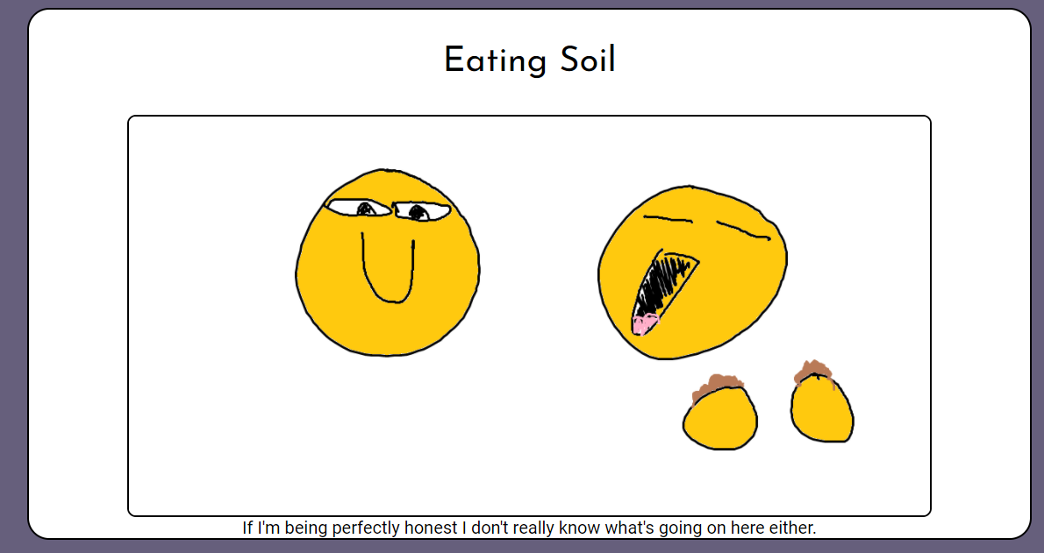

I decided on using a technique to create rounded corner borders for the posts as it made them feel less like large chunks of text and images and more like individual uploads. All of the drawings used in this page are made by me. For now I decided I was done with this page and would come back to it at the end to adjust some details if time permitted it.

Pixel Art Gallery:

The first thing I did was set up the same title design as the other page 

I wanted to use the advanced technique of automation through scripts to create a gallery for my pixel art. I decided to use JavaScript to pull from an array to find a source image and text for each gallery entry instead of manual entry.

First I created a JSON array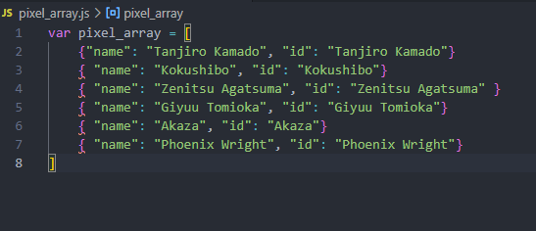

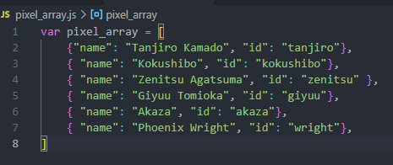Then I realised the filenames weren’t in standard format and rewrote them so they would work

I then wrote code that would create a div and image element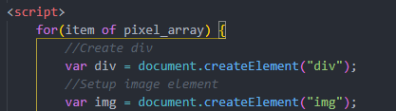

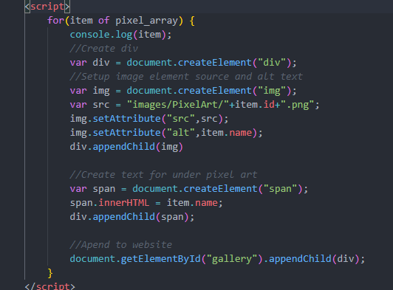

I used this JavaScript automated script in order to pull data from the array, add them as sources for images, alt text and a description of image be added without adding new entries to the HTML. This fulfils the “scripts and automation” section of the complex techniques list. It also optimises my code as there is less jumble in the code itself.

This code draws specific terms from the JSON array it is linked to, uses it to find, name and position images as well as the text describing them and then collects them all in a single div. setAttribute uses the array terms to pick out a source and alt text for an image. appendChild attaches that element to a different div or image.

However at first it was not pulling images or text from the array.

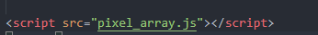I tested this by checking the size of the div on chrome inspect element and found that there was nothing being placed inside it. This was a result of me not calling the JSON array before editing it with a script.

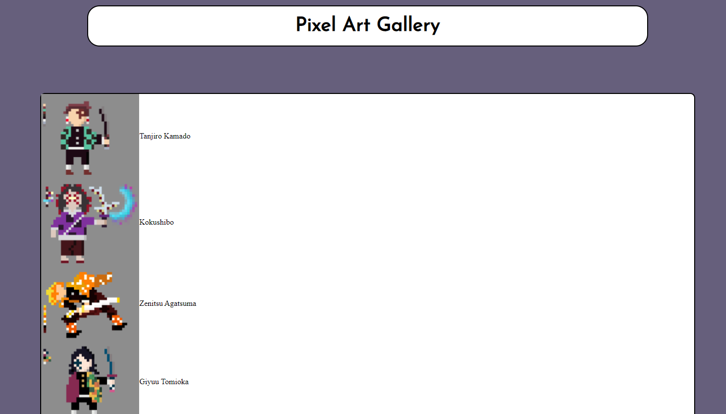After calling the JSON array the scripts pulled the images and the text perfectly but it was not in a gallery as I intended it.

I used the technique of flexboxes to align the images and text horizontally with text below the images.

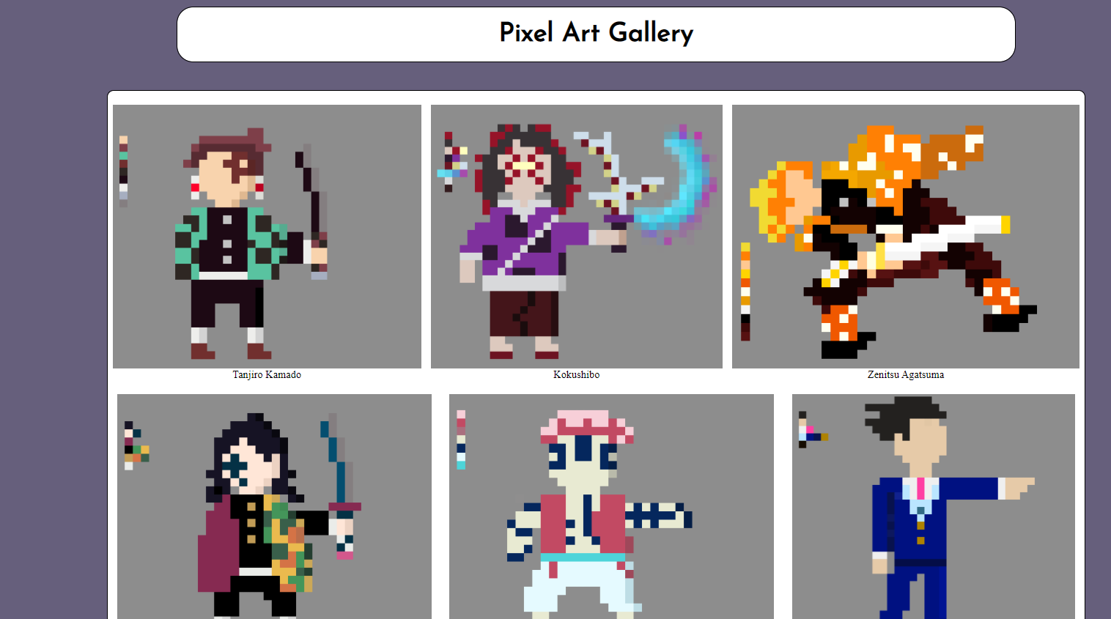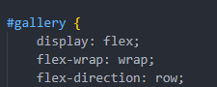 The effect this had on the website is seen below.

I changed the font, text size and background colour to be more appealing to look at.

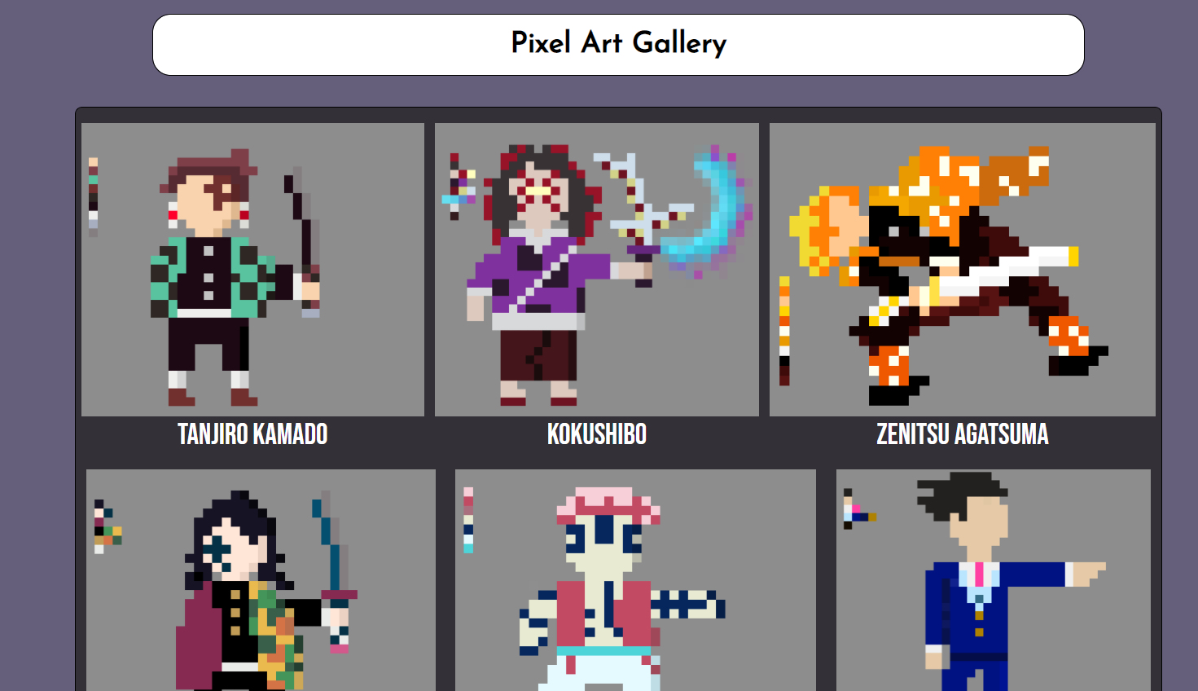However instead of creating new classes and IDs for each section of div, image and span I reused the same class and changed specific parts within it such as all images or all spans. 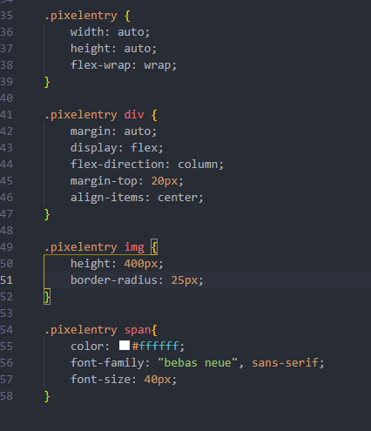

You’ll notice the orange class text is reused several times and the red element text is used alongside it to edit specific sections of the same class.

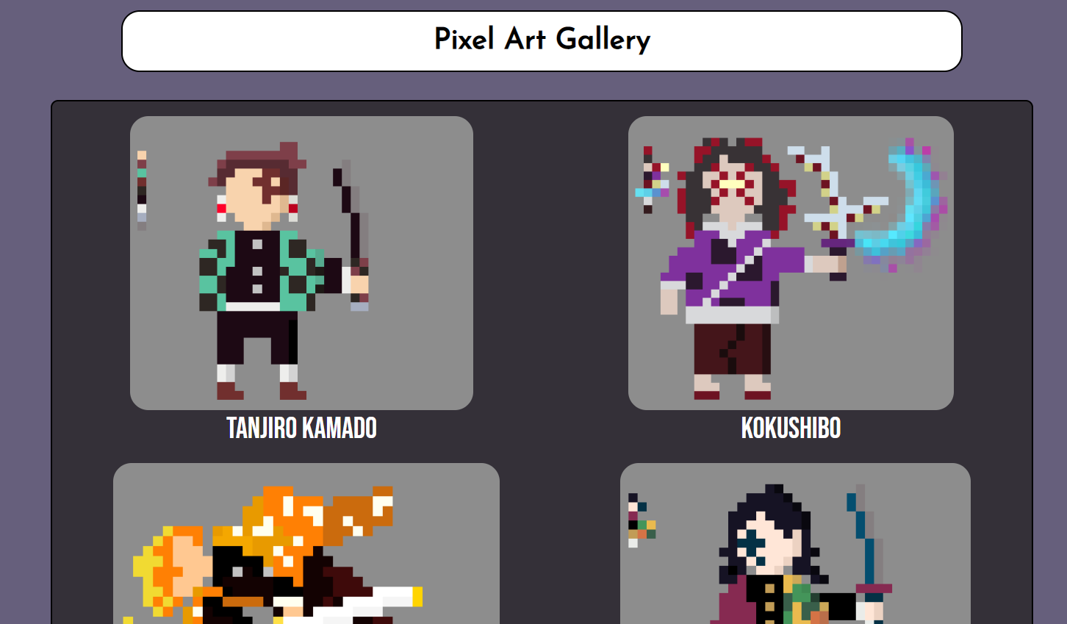This resulted in a more efficient way of loading the website and with a few more aesthetic changes it now had the look of a proper gallery in which more images could be loaded whenever necessary.

Mobile View testing

At first the mobile view was broken and looked like this. It was functional however almost all of the CSS was broken. By adding in some minimum widths I was able to fix the problem. 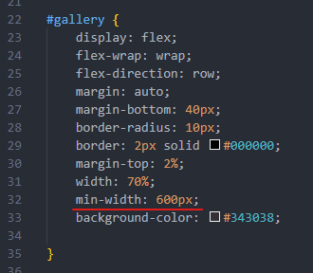

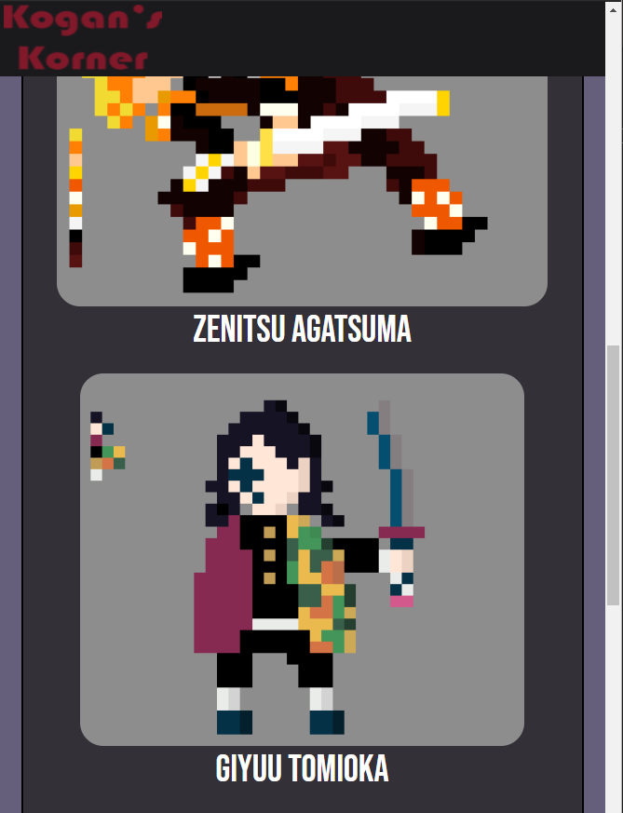

This is the end of the styling of my JavaScript updated gallery.

About me page:

For some cohesion of design I decided to use parallax in my about me page to parallel with my home page design. I first used the same parallax CSS as in my home page and adjusted the background images.

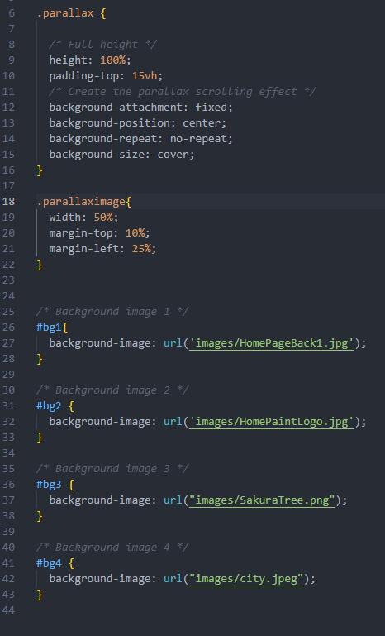

I started with a single image and some text. 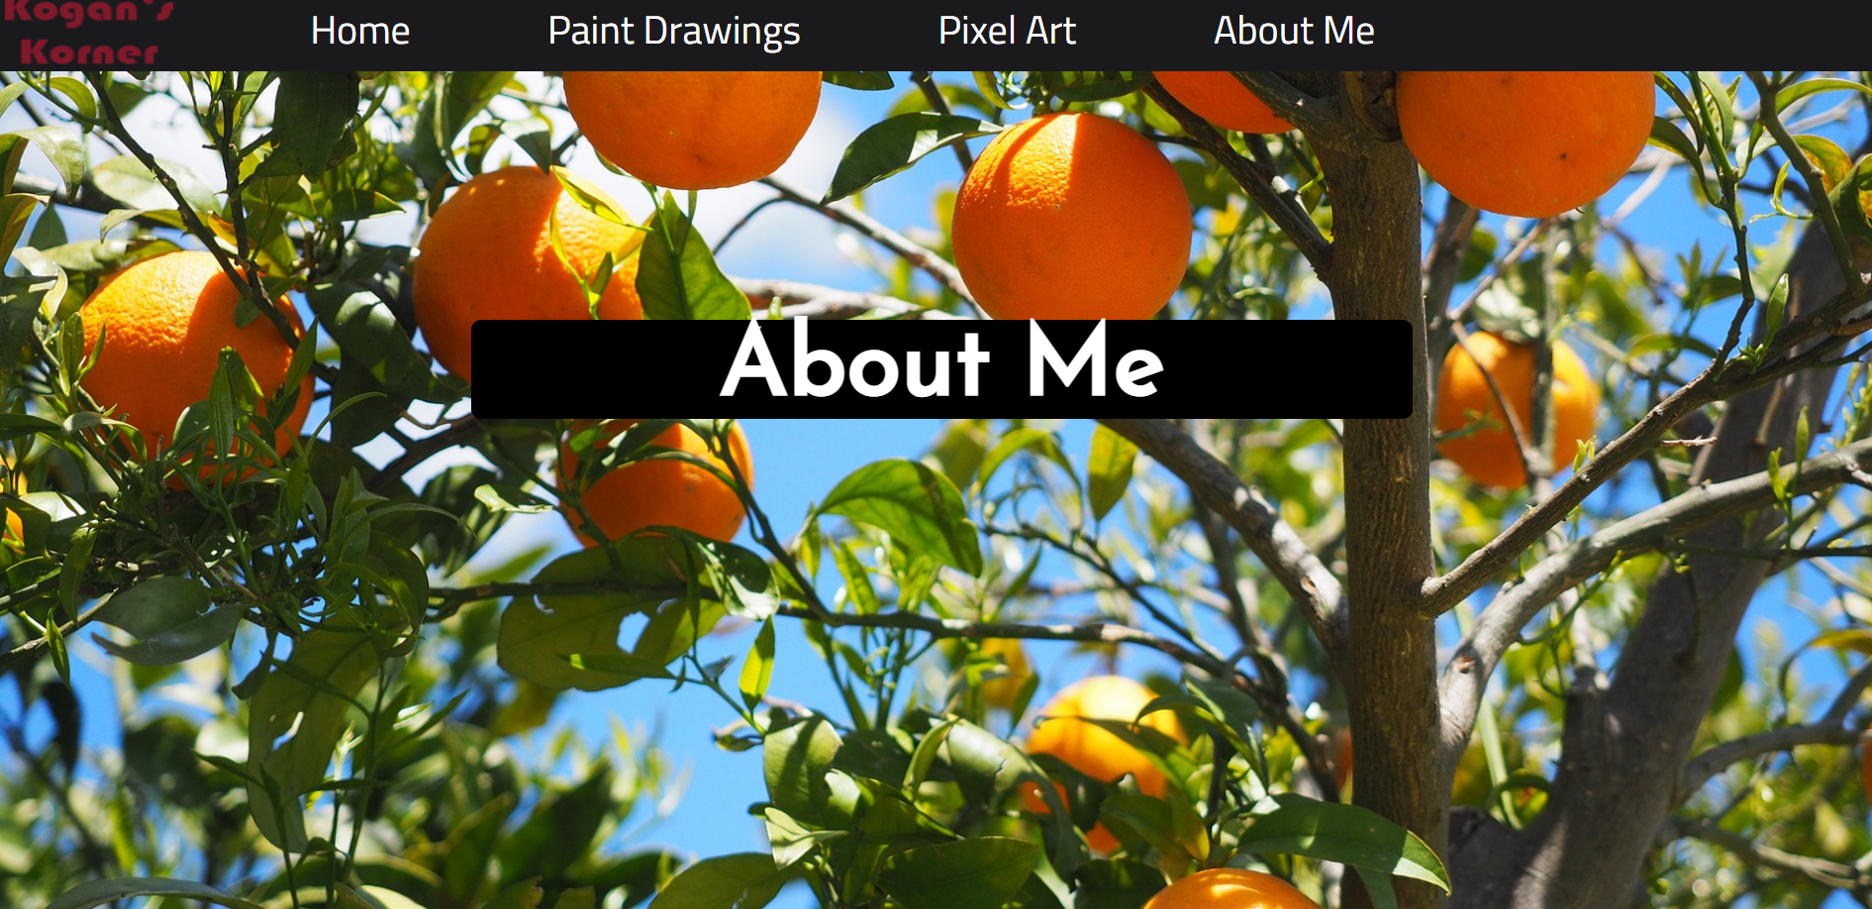

However I decided that the black textbox detracted from the clean parallax. I took away the box however that made the text hard to read

So I found a library for a text-outline online and used it to add some weight. 

Here is an example of a transition swipe between two images. 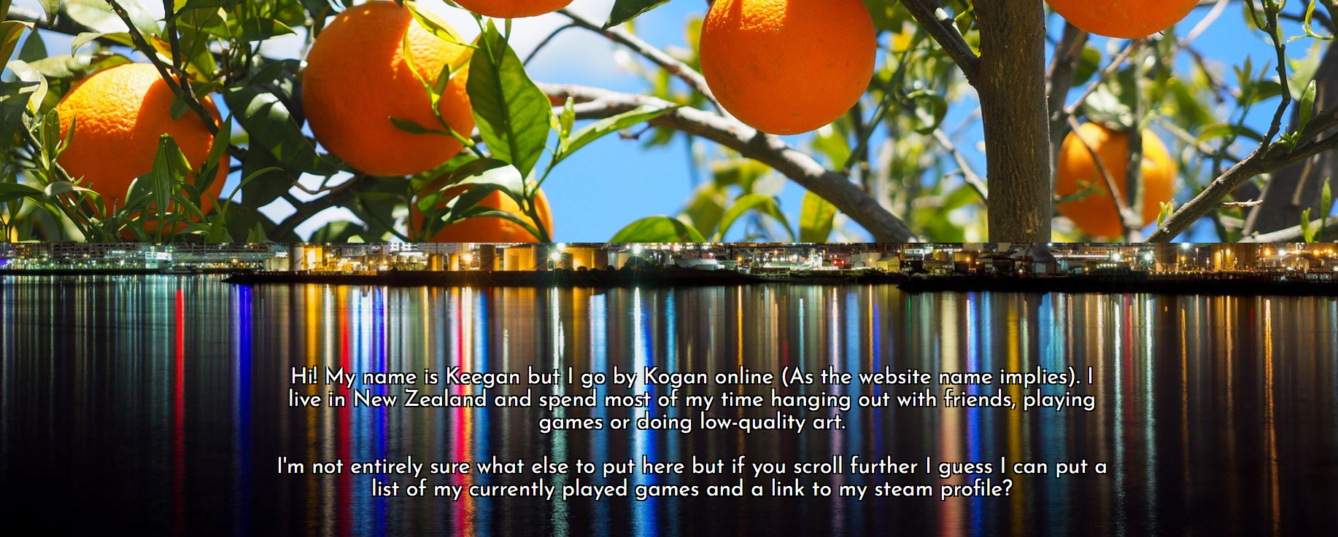

The final image is quite light so I put a black background behind the text and applied an opacity effect so that it would be easier for users to read the text.

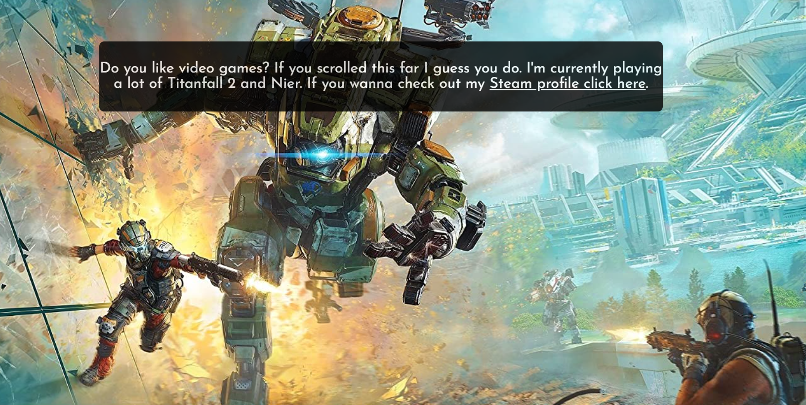

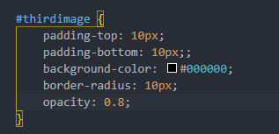

The final thing to do was:

Testing in mobile view:

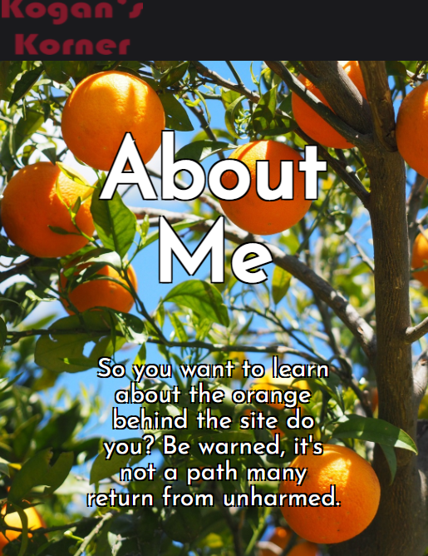I shrank my windows to several different sizes and aspect ratios to test phone view, however because I used code from my homepage that I had already adapted for mobile it worked fine.

With this the stylising of my final page is complete. The website itself is about as good as I thought it would be. One final thing that I almost forgot to do was update the titles of each page as currently the tab would be displayed as “Untitled Garbage” which isn’t exactly a good look. 

# Large redesign of second page:

I chose to recreate the second page from scratch with a parallax design and JavaScript gallery feature as I felt that my previous one was not something I could be proud of.

I started by planning a design with a labelled drawing on a whiteboard.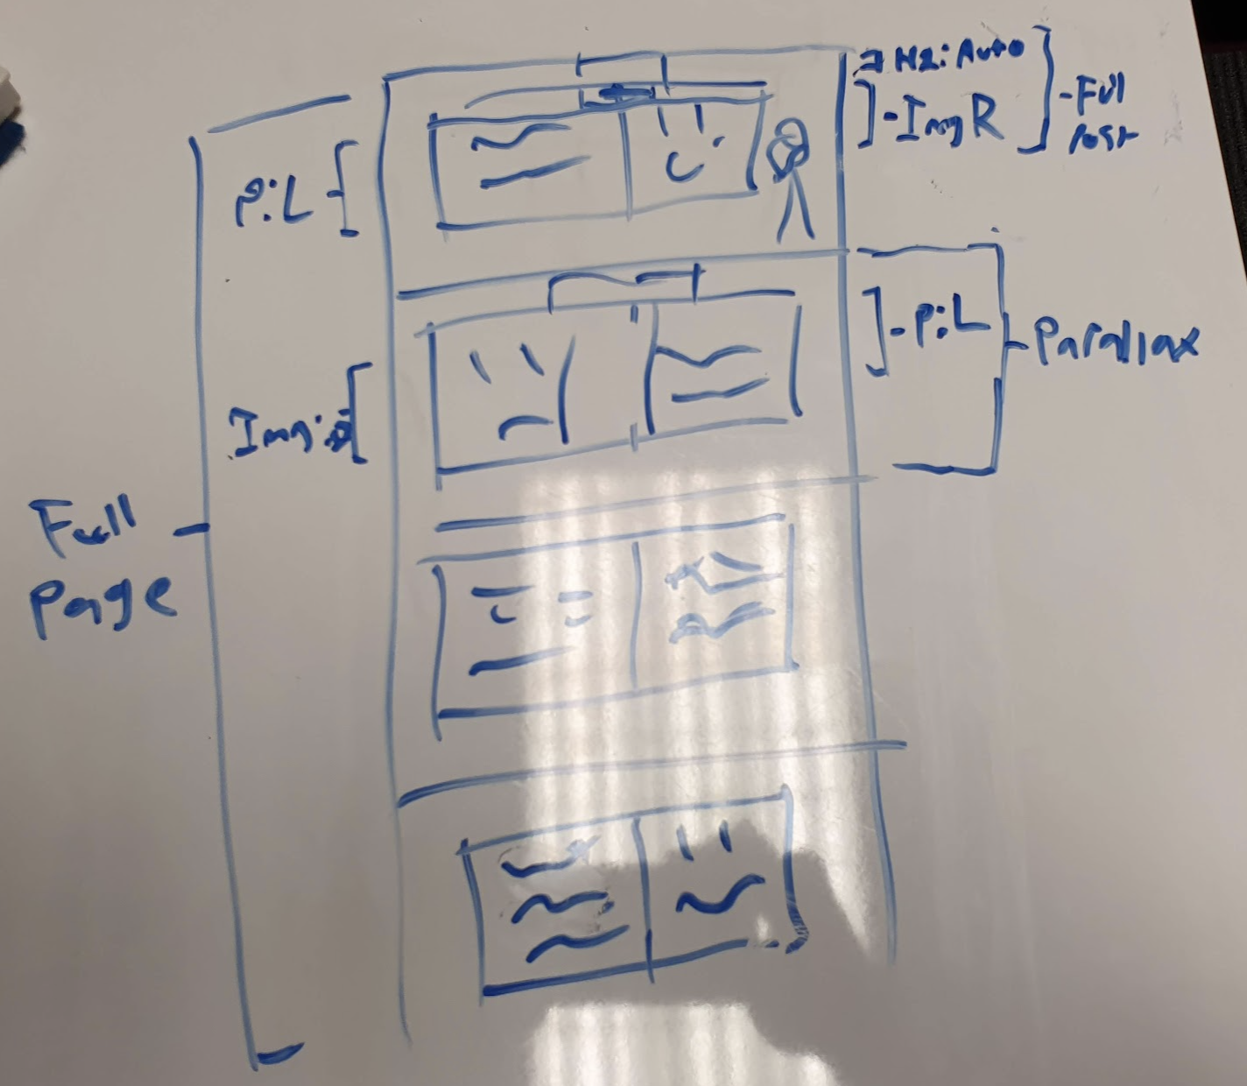

I then set up some CSS for the design:

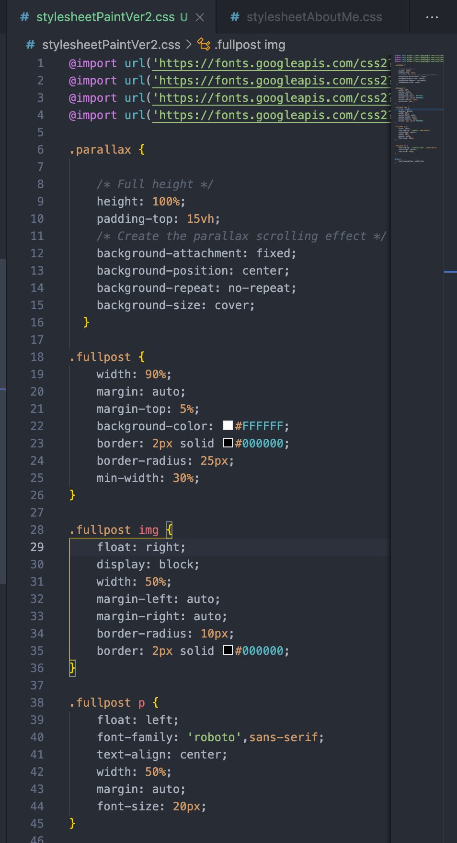

I used a technique called child selectors, which allows you to edit the CSS of specific elements of a class. In this case it lets me set different code for the img, h1 and p elements within the larger fullpost div. The reduces the amount of classes needed, optimising the code and decluttering the files.

I then set up the array that the JavaScript would pull data from, similarly to the pixel art gallery page. 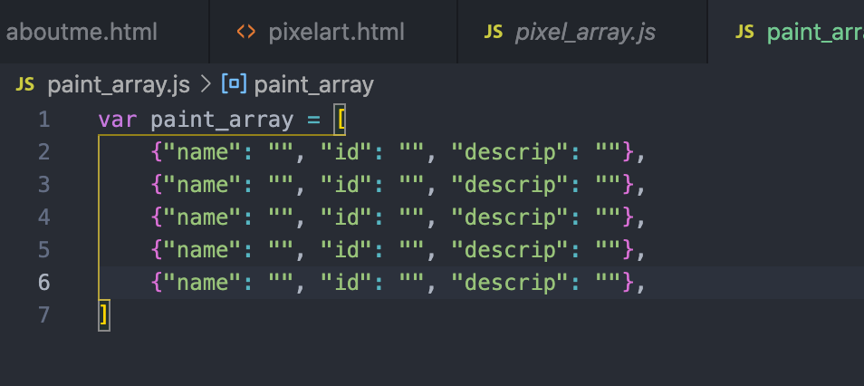

I adapted some code from the pixel art page: 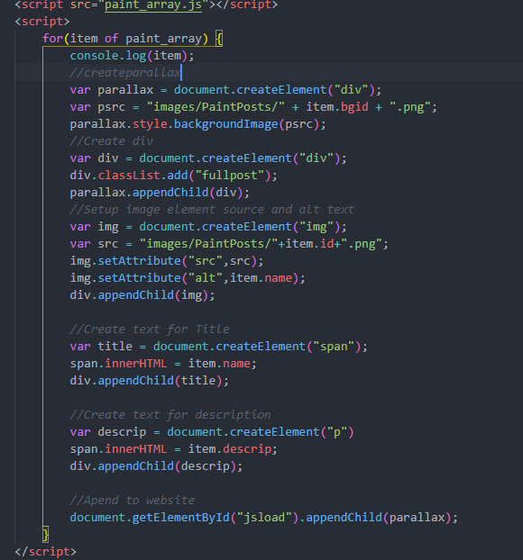

I included this script as it was the easiest way to add new entries to the page and it is another large part of the “advanced techniques: scripts and automation” section of the criteria. The plan is that the JS will draw from an array to select a background parallax image, create a div within that to house the content, place a header in the centre and then add text + image. Document.createElement and item.[ArrayEntry] are commands that will create new objects and take parts from the array written in JS and turn them into a format useable in HTML. classList.add and appendChild apply a CSS class to the created object and then add it to the larger div above it.

However, currently the page remained blank. 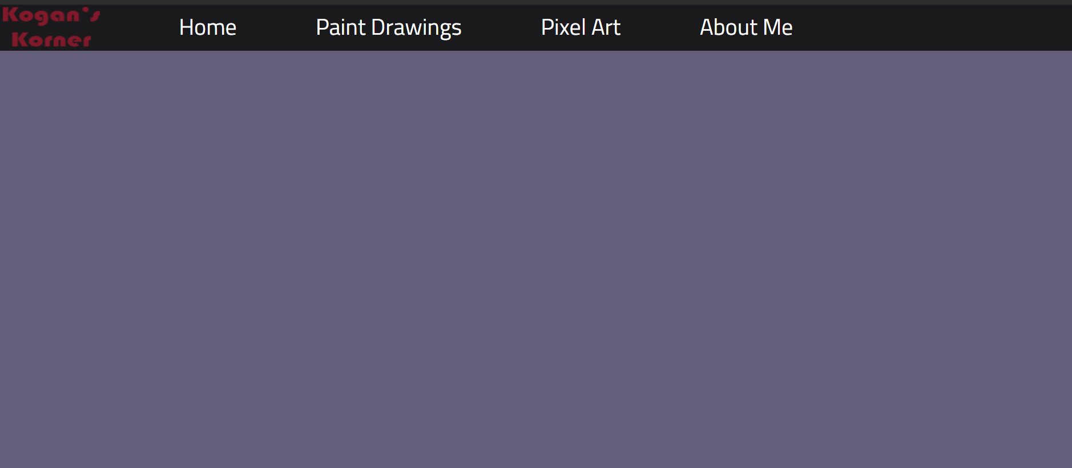

I found that there was an error in my code preventing it from drawing the images and text required.

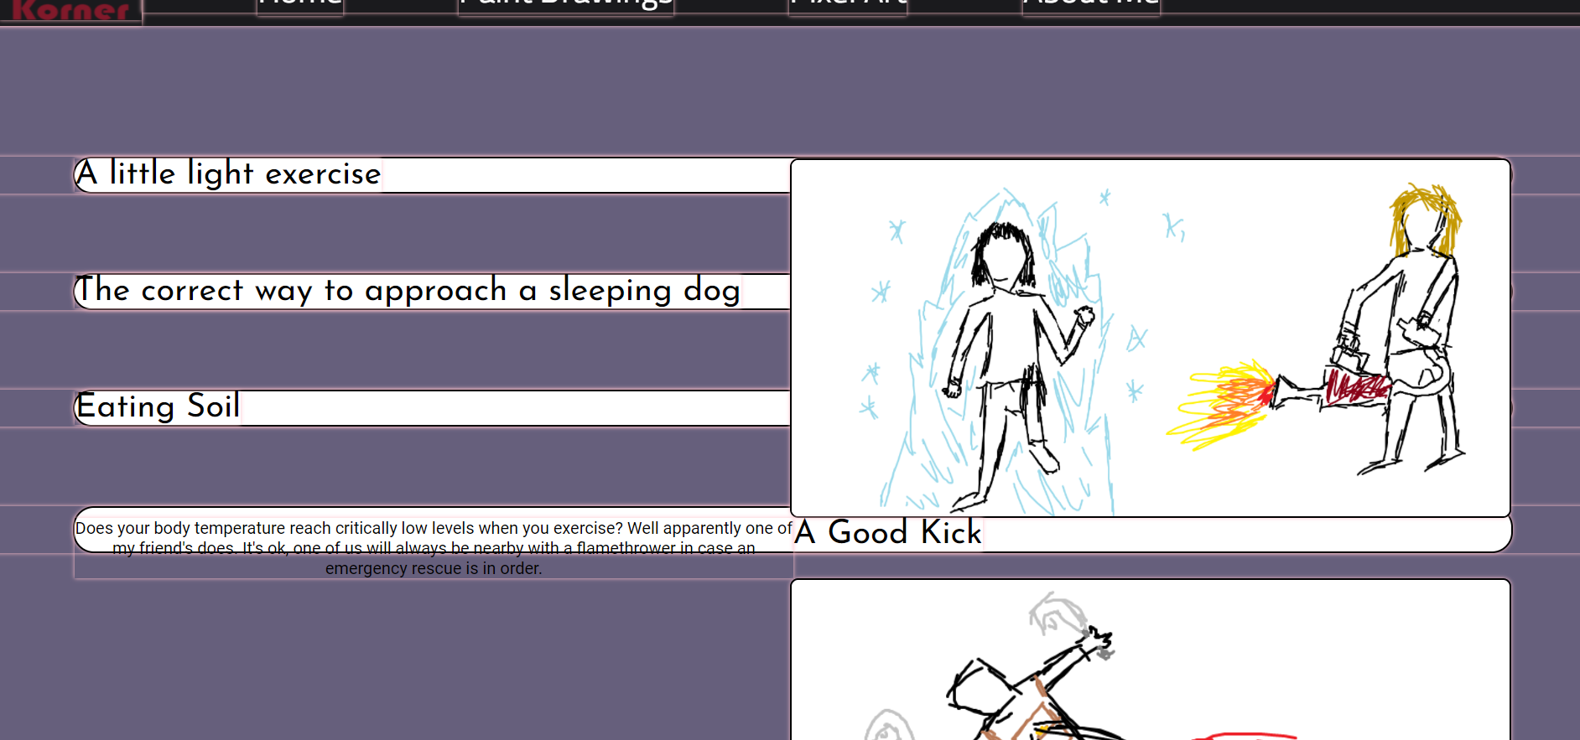

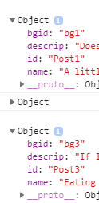 I used the chrome inspect console a print to console command in JS to find the current bugs and saw that it was in fact still drawing the objects it just wasn’t applying the parallax or CSS correctly.

It turned out that I had the wrong form of applying background image in my JavaScript and I fixed it so it looked like this: 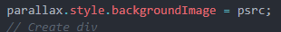

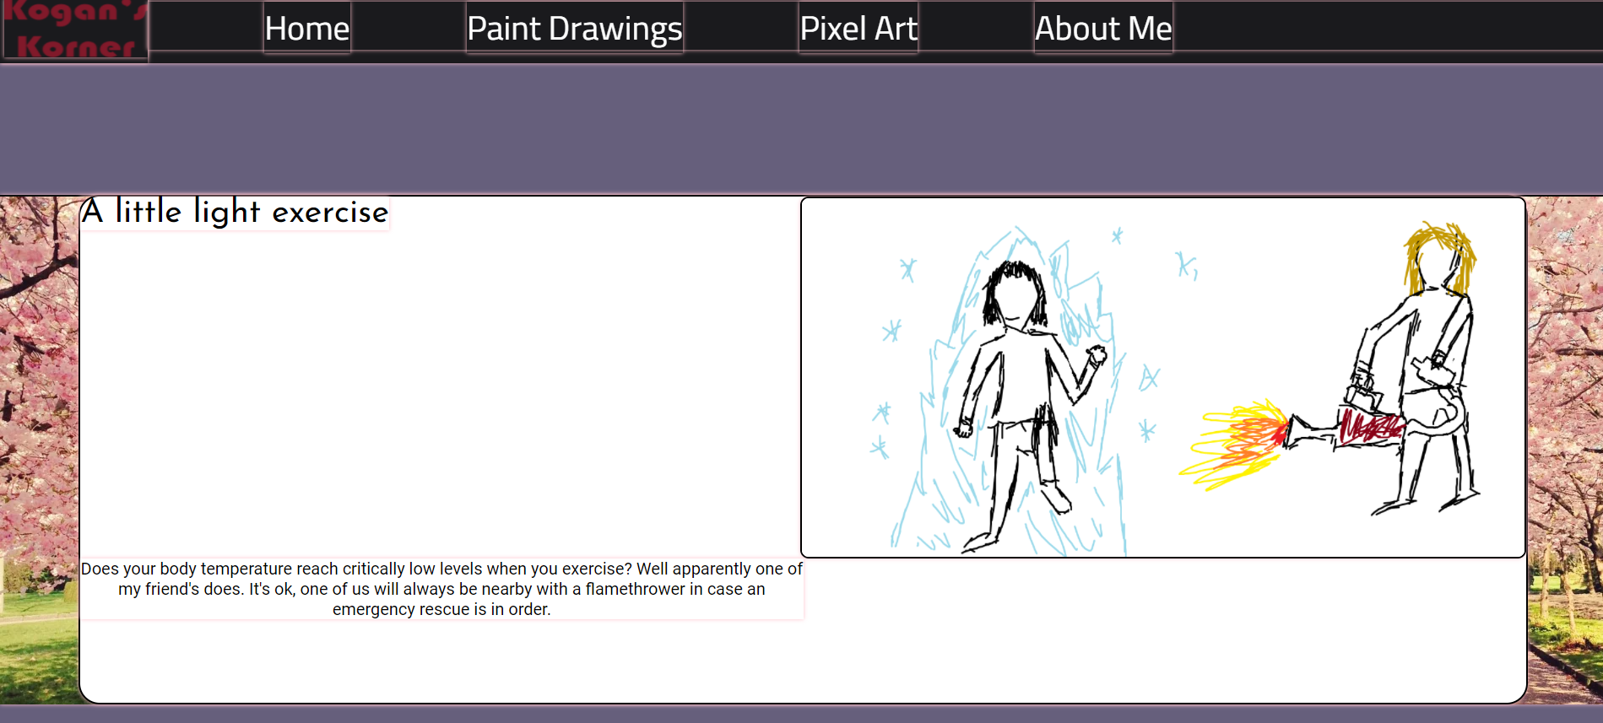

However, this was still not the correct design and it would require some CSS editing.

First I stripped out everything except the parallax segments.

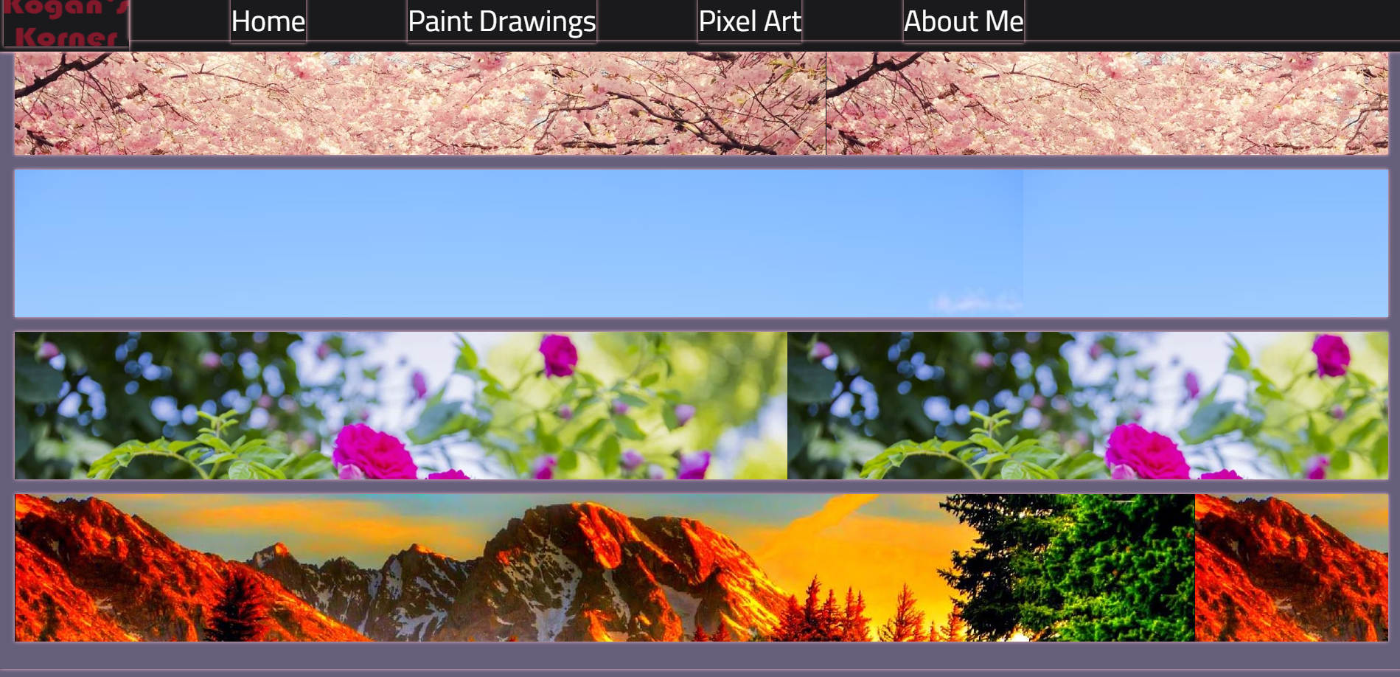

This let me know that the javascript was in fact drawing the images from the folder and creating a div for them.

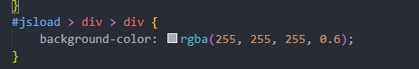

I then used a child selector to add a translucent white background that images and text could be placed on. Child selectors take an ID and allow you to edit all divs below that element. In the example above it is editing the CSS of a div within a div of the top level #jsload element.

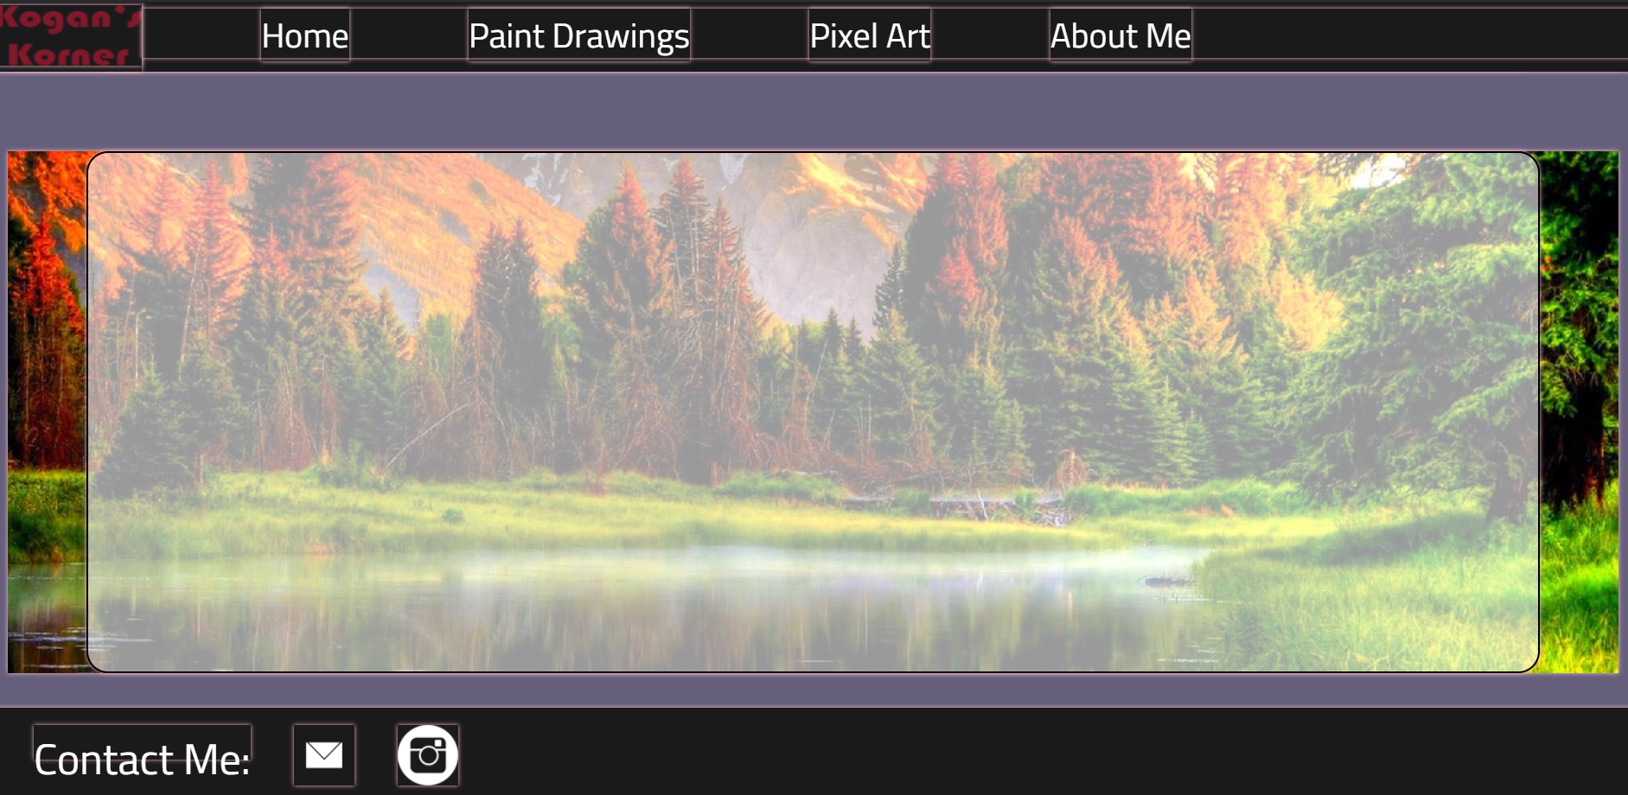

I then un-commented the javascript that pulls the title, images and description from the array and added a bright aqua background to see where is was positioning certain divs. I had to make sure that the title was being placed higher than the image and description. This aqua proved that the javascript was creating elements in the correct order and applying classes to it.

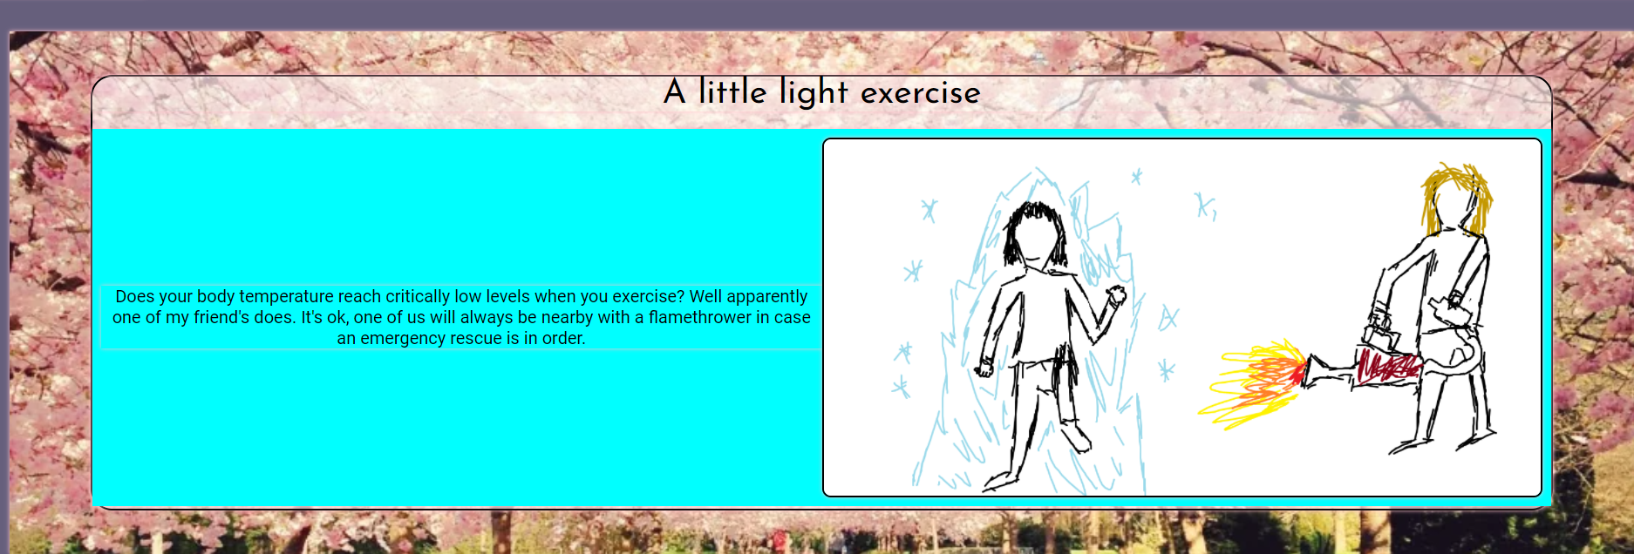

I used a pink outline glow to show the boundaries of every element on my page

This was to make sure that upon resizing the divs would not overlap.

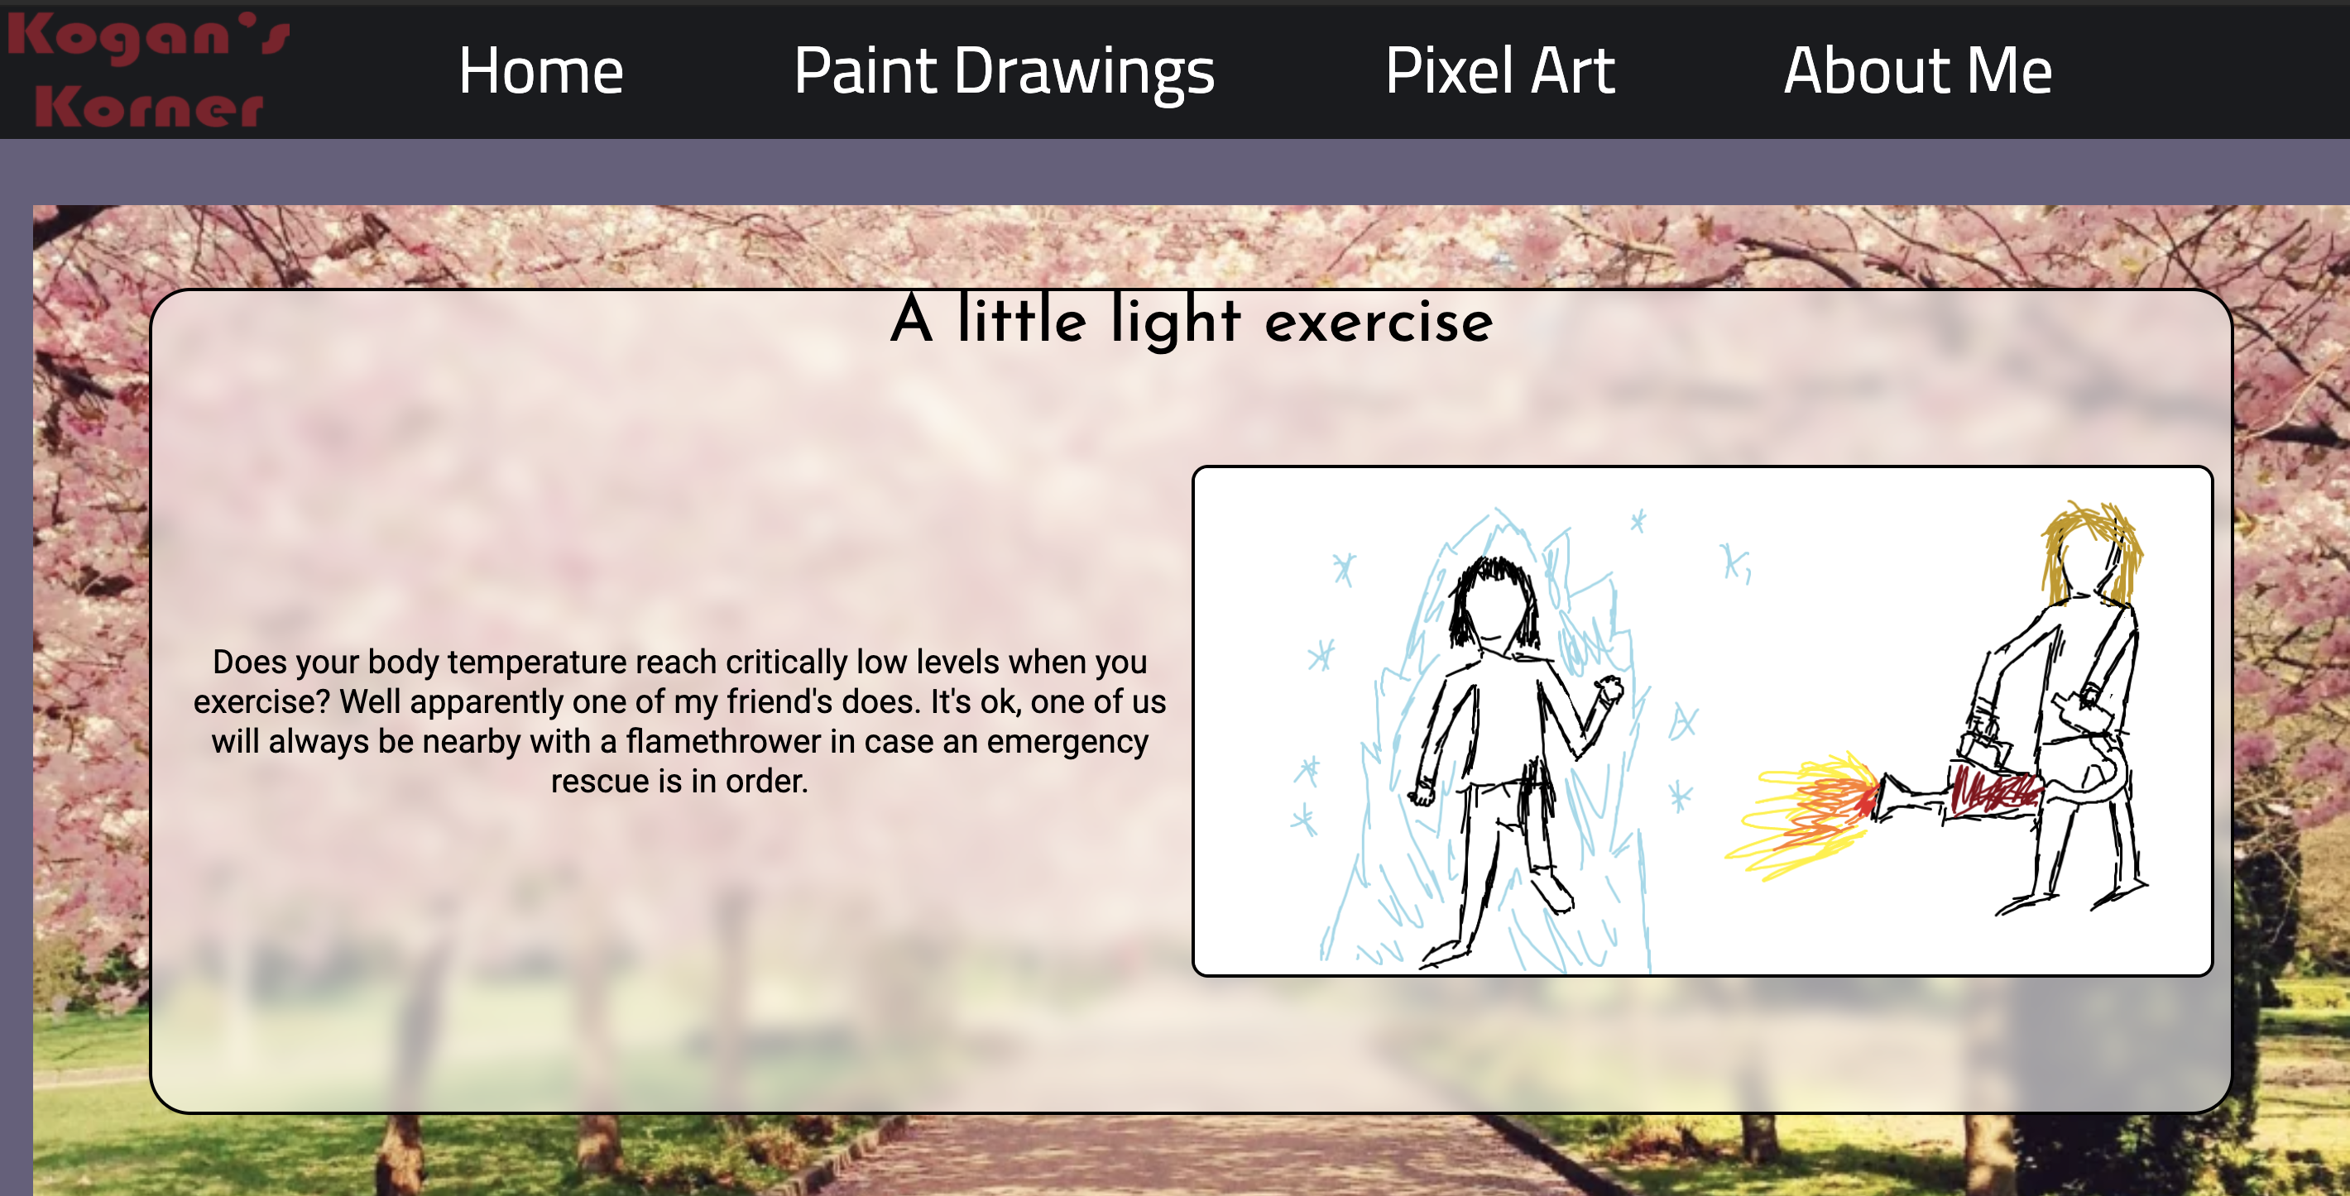And here is a finished example of a restyled div

Reflection on assessment criteria and how I achieved it:

Implications:

Intellectual property: I achieved this implication throughout my website by choosing to draw my own images and make my own art for the Paint and Pixel Art gallery sections. Any other images I used throughout such as the Titanfall 2 poster or picture of Oranges on my About Me page were royalty free and did not require credit to use. I also used my own photo on the home page for the welcome screen. I used a reverse image search to find out who owned a few images used and checked to see if it was the original creator who uploaded them to the royalty free image website and if they did not then I chose not to use those specific pictures. This was all done in order to make sure I adhered to intellectual property rules both legally and morally.

Useability: The useability of a website is decided by a large number of factors. Things such as visibility and expected locations of things are some. I achieved this implication by following design and useability heuristics. Any text is outlined or placed on a contrasting background in order to ensure that it can be read and understood by anybody. My design is consistent by having similar rounded corner designs on all of my gallery pages as well as using a template that has the same header and footer text across all pages. I used the same font families across all pages. Namely Josefine Sans, Roboto and Bebas Neue depending on what type of text I needed. I.e. title text was all in Josefine sans whereas paragraph text was in Roboto. All of my chosen fonts were also sans-serif in order to maintain a modern and consistent design.

I made sure that users could get to pages in several different ways. The first being from clicking any of the labelled buttons on the home page and the second being from clicking page names in the header. This was to make sure that several different types of users would find my website easy to navigate.

Functionality: Assuring the functionality of a website is often one of the hardest parts of creating one. I fulfilled this implication through regular testing of my website in several different resolutions as well as browsers. Throughout my log there are sections labelled “mobile phone testing” or a similar term. These sections show how I adapted parts of my website in order for mobile users to have functionality some examples:

* I used a different type of parallax on my home screen when the width become that of a smartphone so that users on mobile would not lose the advanced technique that I worked on for the sake of design.
* I used a flexbox for the pixel art gallery so that it could automatically resize and reshape the contents when the width became that of a smartphone. Going from a three wide gallery to a single image wide list.

I tested using Mozilla Firefox as well as Microsoft edge however I did not use specific browser-exclusive techniques in my design in order to maintain the functionality I sought.

I also designed a specific part of my website in such a way that it was functionally easier for me, the creator, to update it. In the pixel gallery I used a JSON array and a script in order to automatically pull images from my folder and add them to a labelled div. Now if I wish to add more characters/pieces of pixel art to that page I don’t need to update the HTML section I only need to add the name to the JSON array and it will automatically be added, resized, and styled to match the rest of them.

This was how I fulfilled functionality implications.

Complex techniques:

Sophisticated digital effects: Throughout the design of my website, I used sophisticated and modern digital effects in order to style and write my website. I used parallax scrolling in my homepage and About me page. This is an effect that causes an image to remain static on a page and transition into another image by percentage when the user scrolls. I also used a more advanced form of parallax by making it half-width and caused it to both swap sides and transition between text/link section and image repeatedly.

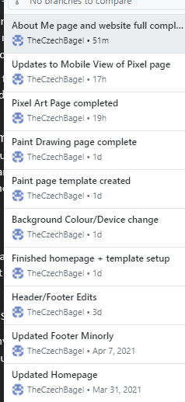On the about me section I included text that it withing the parallax area and moves upwards when scrolled while the background image it is attached to remains stationary during the swipe effect.

Responsive design for use on multiple devices: This was covered heavily in the functionality section, however throughout my log you will find repeated areas in which I test the website in smartphone, tablet and desktop viewing resolutions and angles. If a design was not responsive or functional enough, I rolled it back to one of my previous GitHub commits (pictured here) >>>>>>>>>>  
and build it from the ground up again.

Automation through scripts: This was the most intense complex technique to use. Before starting on this site, I had never used JavaScript within a website. I decided to use a fairly complicated script for this site in order to learn more about webJS. The script that draws and automatically adds images is explained in the Pixel Art page section of my log. It involved creating a .js file with an array and pulling data from it that would automate a process that would normally take over 5 minutes per image uploaded.

Integration of original media assets:

Most of the images used on my website are taken by me and I also designed all of the assets for the Pixel Art gallery myself.

User Experience Principles:

Useability Heuristics for website:

Useability heuristics are considered the gold-standard for web design in order to maximize audience engagement and prevent frustration when using a website. There are several features that should be a part of any project that includes UX or UI design. As a front-end based website is created entirely for their users to view, as opposed to a back-end centric website for data handling and processing, I had to make sure that I could achieve as many of these as possible.

Match between system and the real world: The language used on the website is appropriate to the audience it is designed for. None of the text on the website including headers, footers, paragraph text or JavaScript controlled objects include any references to the code it is written with. This is important as the average user would be able to recognise the term “home” as opposed to a string of text that includes <a> or <h1> tags.

Consistency: Across every page of my website I included the same header, footer, title fonts and colour scheme. I made sure that any div for displaying images or text use a rounded corners design to remain consistent across each page. I used a charcoal colour for both the footer and header as well as for most pieces of title text. If I used background images I used the same advanced form of parallax scrolling.

Simplicity: I didn’t overwhelm the user with options and made sure that a user could get to any of my pages with the least amount of inputs as possible, either 1 or 2 clicks. I made sure that I had a simple header with clear titles and any clickable objects on a page had as clear charcoal box design that matched the colour scheme of my website. E.g the link box elements on my home page matches the colour of my header and footer.



Users never have to work with systems that take time to learn or understand and most elements are simply part of the page, not objects that users must interact with.

User control and freedom: When I designed my navigation bar and home page I made sure that users had several different ways of navigating the page. I.e. They could either use the header to swap pages or they could scroll through the home page and click any of the boxes directing them to other pages. A website is not designed to be a linear experience, it should be created so that users can access the content they want to see most at a first glance.

Aesthetic and minimalist design:

My design did not overwhelm the user with options and designs. All interactive elements and links were labelled clearly. While the design of the website itself was not on the level of a professional designer I made sure to follow modern colour and web design conventions such as no auto playing gifs or clashing colour designs. All of the dialogue boxes use the same fonts, styles and sizes if possible. There are no unnecessary elements with file sizes that would cause the website to lag upon loading.